**Press release May 2017**

Children’s Heart Surgery Fund is asking for your donations over Ramadan to help support children and adults living with congenital heart disease across Yorkshire.

The charity launched their **Keeping the Beat** appeal, to fund a revolutionary new children’s heart theatre at the Leeds General Infirmary, in May 2016.

Support for the £500,000 appeal has been incredible and the halfway point was reached after just seven months, but this momentum needs to continue.

The new theatre is critical to both the health of congenital heart disease patients in the region, and the integrity of the hospital which needs the new theatre to fulfil clinical standards set by NHS England.

As well as open heart surgery, the new theatre will be used for delivering all minimally invasive heart procedures by cardiac catheter on babies and children. This will mean shorter waiting times, less invasive procedures and faster recoveries.

5-month old Areeb Iftakhar arrived at the Leeds Congenital Heart Unit in an extremely serious condition. He has a congenital heart defect called ALCAPA, which means his left coronary artery is connected to the pulmonary artery instead of the aorta.

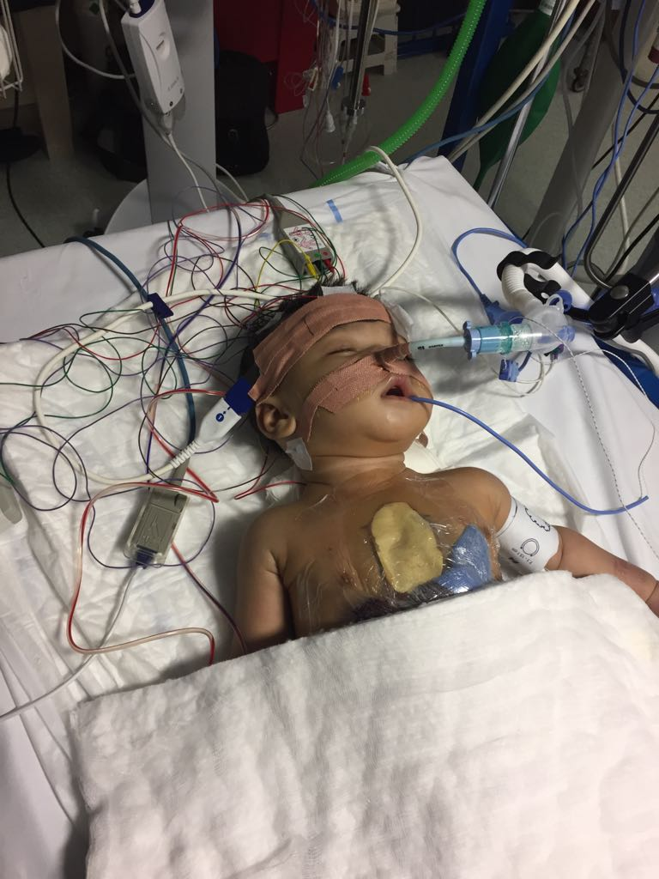 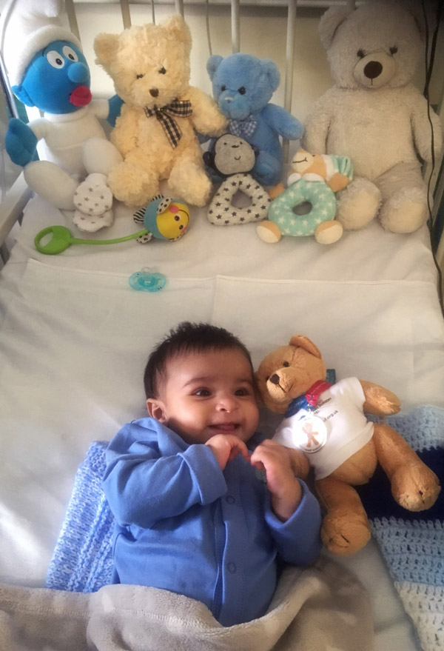

**Areeb being treated at LGI Areeb recovering post-surgery**

Areeb had open heart surgery in April aged just 5 months and went through a cardiac arrest, but the surgical team at Leeds saw him pull through. Following periods in Intensive Care and on the ECMO (artificial heart and lung support) machine funded by CHSF, he is now spending time recovering in Ward 51.

Areeb’s mum Salma said: “The charity does so much. All around the ward you can see equipment provided by Children’s Heart Surgery Fund, from little things like DVD players to life-saving heart machines.”

“It’s great to know the charity are bringing a new theatre to Leeds to keep ahead of this disease.”

Areeb’s family are based in Rotherham, and the charity also funds family accommodation at the hospital.

Salma added: “We don’t know what we would have done without the parent accommodation. It’s really important to have somewhere really near to rest and build up your strength when you’re going through such an emotional and draining time.”

With your support, we can continue to support congenital heart disease patients today, and keep Yorkshire at the forefront of cardiac care for the future.

Donate today to save lives. Visit our website at chsf.org.uk/donate, text CHSF17 £10 to 70070 or call 0113 392 5742.

You can find out more about **Keeping the Beat** at chsf.org.uk/keeping-the-beat.

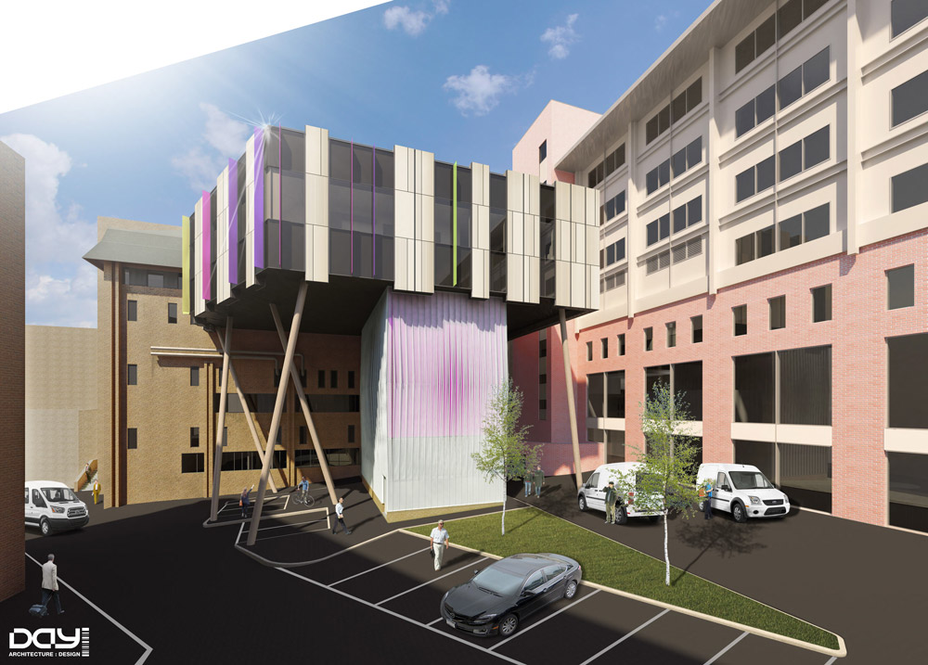

**Draft of the new children’s heart theatre**

From all at Children’s Heart Surgery Fund, Ramadan (and Eid) Mubarak!

**EndsNotes to Editors**Children’s Heart Surgery Fund is the award-winning charity based in Leeds and supporting the Leeds Congenital Hearts service – which serves the whole of Yorkshire, the Humber and North Lincolnshire. Our vision is for children to live life, beating heart disease, and our mission is to make the Leeds Congenital Hearts unit a world class centre of excellence by providing the funding and resources needed to care for a child's heart, mind, family and future. **See www.chsf.org.uk for more information.**For more information, and to arrange interviews before, during and after Ramadan, please contact: **Andy McNally, Marketing and Communications Manager, 0113 392 2948,** [andy.mcnally@chsf.org.uk](mailto:andy.mcnally@chsf.org.uk).

More detailed version of the images available on request.