MEDIA RELEASE - 09/04/2019
For immediate publication

BRITISH ARTISTS AND FORMER CULTURE MINISTER ED VAIZEY MP TO DEBATE FUTURE OF ART IN HEALTHCARE AT LANDMARK EVENT

National charity Paintings in Hospitals will mark 60 years of transforming the UK’s health and social care spaces with a unique event on the future role of visual arts in healthcare – to be held in London next month.

The Framing the Future panel will feature internationally acclaimed artist and author Edmund de Waal OBE; Dr Errol Francis, CEO of Culture&; Dr Val Huet, CEO of the British Association of Art Therapists; Prof. Victoria Tischler, Professor of Arts and Health at the University of West London; and Ed Vaizey MP, Chair of the All-Party Parliamentary Group on Arts, Health and Wellbeing.

The panel will consider the past pioneers of arts in health, including Paintings in Hospitals as the first and only national art collection dedicated to improving health and wellbeing, as well as anticipated future innovations in the use of art to improve the lives of patients, service users and carers.

Framing the Future is part of a series of events throughout 2019 to celebrate Paintings in Hospitals’ 60th anniversary and the difference the charity has made to the nation’s physical and mental health since its founding in 1959. The panel discussion will be followed by networking drinks.

Ed Vaizey MP, former culture minister and chair of the APPG on Arts, Health and Wellbeing, said:
“I am delighted to be part of this inspirational event. Art plays such a major part in all our lives, not least when we are at our most vulnerable, sick or in need of the emotional or spiritual comfort that art can provide. The future signals much change, both in healthcare and in the arts, so it’s crucial we talk about how the next 60 years of Paintings in Hospitals’ and the sector’s work can continue to benefit patients and their families across the UK.”

Ben Pearce, Director of Paintings in Hospitals, explained why the event is so timely:
“For six decades, we have been working across every type of care organisation to transform the UK’s health through art. Art is proven to help us stay well and aid our recovery from illness. We also know art has the potential to save the NHS money. In these challenging times, it is vital we highlight the enormous contribution visual arts have made and can further make to public health in the future.”

- Journalists are welcome to attend the event (see below to secure a place). We are also able to offer the opportunity to meet with the panellists and for exclusive interviews with: Ben Pearce (Director of Paintings in Hospitals), Professor Victoria Tischler and other trustees of Paintings in Hospitals. Please enquire for further details.
ENDS

Event Details

Title: Framing the Future

Date/Time: Monday 13 May 2019, 18:00 - 20:45

Venue: Royal College of Physicians (Auditorium)

11 St Andrews Place, London, NW1 4LE

Tickets: Standard: £15; NHS Staff Concession: £12

Website: www.paintingsinhospitals.org.uk/framing-the-future

Media Enquiries

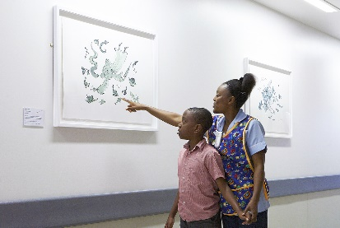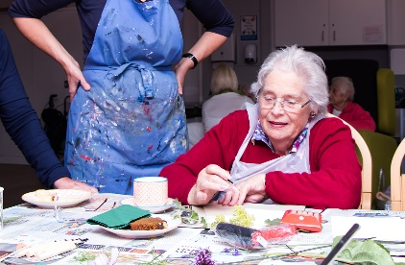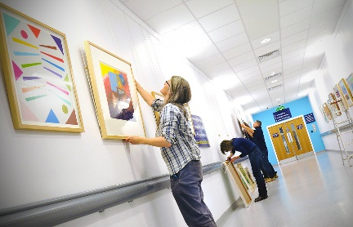

For further details, hi-res images or interview requests, please contact:

Thomas Walshaw, Communications & Development Manager, Paintings in Hospitals

T: +44 (0)207 407 3222, E: t.walshaw@paintingsinhospitals.org.uk

Editor’s Notes
ABOUT Paintings in Hospitals
Founded in 1959, Paintings in Hospitals was an early pioneer of the now flourishing ‘arts in health’ sector and remains the only national art collection dedicated to inspiring better health and wellbeing for patients and carers. Paintings in Hospitals is partnered with 180 health and social care organisations in England, Wales and Northern Ireland, loaning its artworks and hosting hands-on art workshops to create care spaces that encourage, enrich and empower everyone who uses them.

The Paintings in Hospitals collection holds 4,000 artworks, including pieces by Bridget Riley, Antony Gormley, Ian Davenport, Maggi Hambling, Andy Warhol, Anish Kapoor, Howard Hodgkin, Patrick Caulfield, Helen Chadwick, Sonia Boyce, Alexander Calder, and many more. Paintings in Hospitals has also partnered with national museums and collections, including the V&A, Arts Council Collection and Wallace Collection, enabling the charity to bring more world-class art to people who cannot reach it alone. Paintings in Hospitals receives no Government funding and relies entirely on grants and donations to continue its unique work. Paintings in Hospitals is a Registered Charity (1065963).

Website: www.paintingsinhospitals.org.uk

Twitter: @artinhospitals

Instagram: @PaintingsinHospitals

Facebook: @PaintingsinHospitals

END

