CHRISTMAS HOLIDAY COURSES
AT THE ROYAL DRAWING SCHOOL

Adult Courses: 6 -10 December 2021 and 10 – 14 January 2022
Young Artists Courses: Saturday 11 December 2021

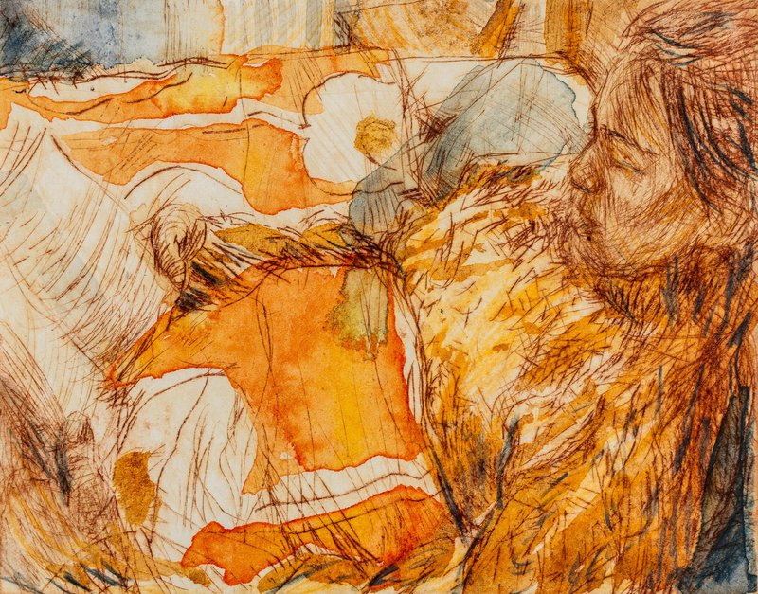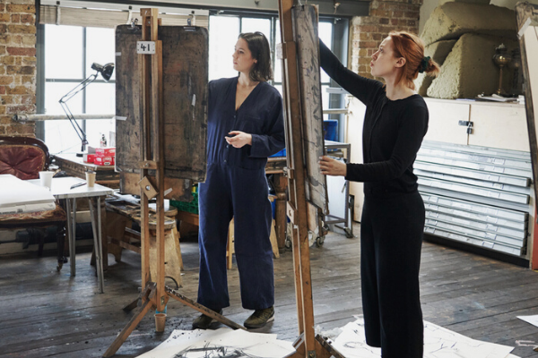
Drawing by Leo Macdonald Oulds

We have a great range of in studio and online Christmas courses this year, so there will be something creative to fit around your busy holiday schedule.

Each course is a one-week, intensive period of study and practice, allowing experienced or budding artists to immerse themselves in drawing, painting or printmaking. We have new courses as well as returning favourites to encourage you into the studio this winter.

Highlights include the new course Drawing the Figure: The Studio as a Stage which will use theatrical set-ups to explore composition and the figure. Drawing, Painting and Materials: Internal Landscapes is an online course in which we will explore the domestic objects of everyday life around us, working from still life and surrealist traditions.

The Etching Week provides the opportunity to expand your skills in a supportive and directed environment, whilst new course Experimental Printmaking in the Life Room combines working from the model with print techniques to give students a new and unique way of responding to the human form.

Young Artists (10-15 yrs) can discover the art of the seasonal pantomime or explore the history of printmaking this Christmas through a one-day workshop on 11th December.

Adult Course listings:

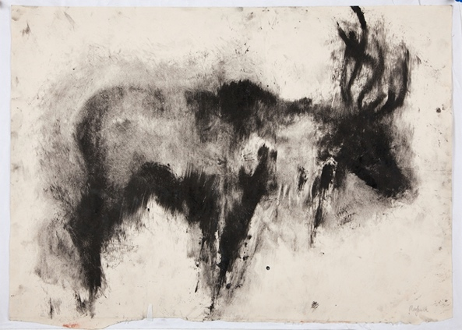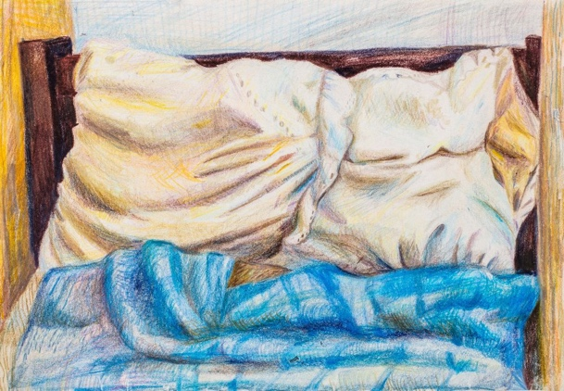
Print by Meg Buick; drawing by Rose de Borman

6 – 10 December 2021: Studios

The Drawing Week
Various tutors, 10am - 5pn
£455.00
Shoreditch studios
www.royaldrawingschool.org/courses/public-courses/christmas-holiday-the-drawing-week-studio/

Life Painting
Andy Pankhurst
10am – 5pm
£ 455.00
Shoreditch studios
www.royaldrawingschool.org/courses/public-courses/christmas-holidays-life-painting/

Drawing the Figure: The Studio as a Stage
Sophie Charalambous, Harriet Miller
10am – 5pm
£ 455.00
Shoreditch studios
www.royaldrawingschool.org/courses/public-courses/christmas-holiday-drawing-and-materials-the-studio/

The Etching Week
Maggie Jennings
10am – 5pm
£ 455
www.royaldrawingschool.org/courses/public-courses/christmas-holiday-the-etching-week/
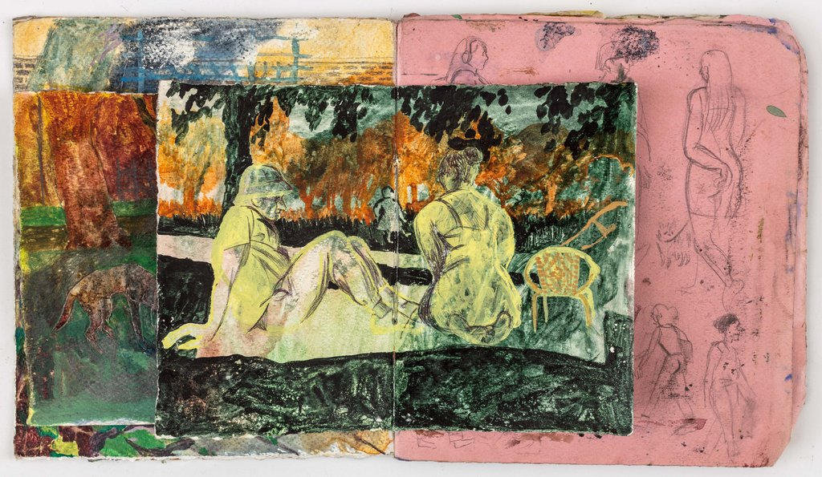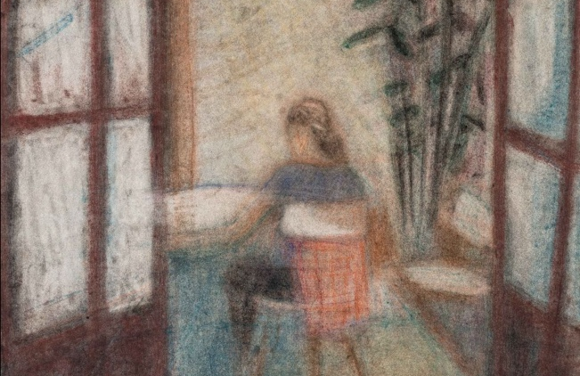
Collage by Lucile Haefflinger; drawing by Harry Clitheroe

6 – 10 December 2021: Online

Collage, Poetry and Imagination
Perienne Christian , Rosie Vohra
10am – 5pm
£ 450.00
Online
www.royaldrawingschool.org/courses/public-courses/christmas-holiday-collage-poetry-and-imagination/

Winter and Watercolour: Immersive Narratives
Rebecca Harper, Melissa Kime
5.30pm – 8.30pm
£ 195.00
Online
www.royaldrawingschool.org/courses/public-courses/christmas-holiday-winter-and-watercolour-immersive/

Drawing, Painting and Materials: Internal Landscapes
Lindsay Sekulowicz, Clare Newbolt
10am – 5pm
£ 450.00
Online
www.royaldrawingschool.org/courses/public-courses/christmas-holiday-drawing-painting-and-materials-i/

10 - 14 January 2022: Studios and out of House

Drawing into Painting
Sophie Charalambous, Harriet Miller
10am – 5pm
£ 455.00
Shoreditch studios
www.royaldrawingschool.org/courses/public-courses/christmas-holiday-drawing-into-painting/

Painting a Head
Ishbel Myerscough, Sharon Brindle
10am – 5pm
£455.00
Shoreditch studios
www.royaldrawingschool.org/courses/public-courses/christmas-holiday-painting-a-head/

Experimental Printmaking in the Life Room
Rossen Daskalov, Jake Garfield
10am – 5pm
£ 455.00
Shoreditch studios

www.royaldrawingschool.org/courses/public-courses/christmas-holiday-experimental-printmaking-in-the-/

Drawing at The National Gallery
Robert Dukes, Andrea McLean
10am – 5pm
£ 455.00
Out of house | The National Gallery
www.royaldrawingschool.org/courses/public-courses/christmas-holiday-drawing-at-the-national-gallery/

10 - 14 January 2022: Online

Painting the Contemporary Portrait

Clara Drummond, Rachel Mercer
10am – 5pm
£455.00
www.royaldrawingschool.org/courses/public-courses/christmas-holiday-painting-the-contemporary-portra/

The Drawing Week (Online)
Various tutors
10am – 5pm
£ 450.00
www.royaldrawingschool.org/courses/public-courses/christmas-holiday-the-drawing-week-online/

Ink, Mindfulness and Expression
Nicola Durvasula, Mathew Cunningham
5.30pm – 8.30pm
£ 195.00
www.royaldrawingschool.org/courses/public-courses/christmas-holiday-ink-mindfulness-and-expression/

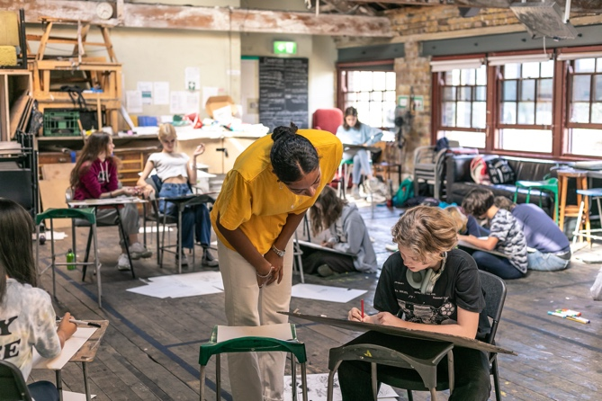. 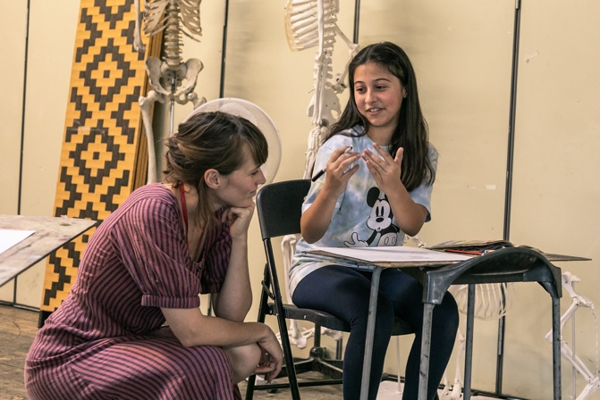

Young Artists Winter Holiday Courses (ages 10-15 years)

Printing Festive Feasts
Saturday
11 December 2021
10am – 4pm
£75, Shoreditch Studios
www.royaldrawingschool.org/courses/public-courses/young-artists-winter-holiday-course-aged-10-15-yea/

Let’s Draw the Stage
Saturday
11 December 2021
10am-4pm
£75, Shoreditch Studios
www.royaldrawingschool.org/courses/public-courses/young-artists-winter-holiday-course-2-aged-10-15-y/

NOTES TO EDITORS

Address: 19-22 Charlotte Rd, London EC2A 3SG
Website: www.royaldrawingschool.org
Twitter: @royaldrawing
Instagram: @royaldrawingschool
Facebook: @royaldrawingschool

Press enquiries: Elizabeth Morrow, Marketing and Communications Coordinator Elizabeth.morrow@royaldrawingschool.org / 07954412107

Press Images: bit.ly/RDSXmas (Password: RDSChristmas)

Royal Drawing School

The aim of the Royal Drawing School is to raise the standard and profile of drawing through teaching and practise. Located in Shoreditch, East London, it is one of only a few institutions in the world offering in-depth, quality tuition in drawing from observation.

Founded in 2000 by HRH The Prince of Wales and artist Catherine Goodman, the Royal Drawing School runs The Drawing Year, an intensive postgraduate-level programme offering up to thirty students the opportunity to focus on drawing from observation for one academic year. All students are awarded a full scholarship, studio space and receive tuition from a distinguished faculty of over 75 practising artists. In addition to The Drawing Year the School runs a Public Programme of daytime and evening drawing courses; a Young Artists Programme for children and young people aged 10-18 who have a passion for drawing; a School Leaver’s course for 18–19 year-olds who are considering an arts degree or a career in the creative industries and an International Residencies Programme in countries including; Scotland, Wales, Italy, the USA Antigua and Jamaica. Fees are heavily subsidised, and a comprehensive concessions scheme ensures that the School’s courses are accessible to the widest array of students.

