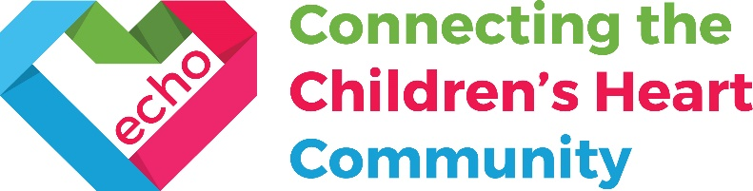

Top local bands put on music festival in Diss to raise money for children’s charity

On Saturday 11th April from 1pm - 10pm, there’s a chance to catch eleven of the region’s top acts, who’ll be playing a one-off music “festival” at the Corn Hall in Diss to raise awareness and money for children’s charity ECHO.

Amongst those appearing will be a former member of hit 80s band “Then Jerico” (Jasper Stainthorpe, bass player in The Magic Es) and a songwriter whose work has been covered by music giants REM (Tony James Shevlin). As well as the musicians, there’ll be children’s entertainment provided by Imps Creativity, so it really is a day for all the family - and in a very good cause.

Local musician and organiser Pete Thompson, who lives in Dickleburgh, wants to raise as much money as possible for ECHO, a charity who provide support for children with heart conditions - and their families.

Pete Thompson, event organiser:

“My daughter was diagnosed with a serious heart condition before she was born, and as you
can imagine, that’s every parent’s worst nightmare. Getting support from ECHO - telling us as parents what to expect, and putting us in contact with other families in the same situation - was a life-line at an incredibly stressful time. I really want to give something back to say “thank you” to this great charity (who don’t get any NHS or government funding), so I’ve got the best local bands I know to come and give their time and talent to help raise money for this cause that is - no pun intended - so close to my heart.”

Samantha Johnson, ECHO’s Chief Executive:

“We at ECHO are honoured to be supported by heart dad Pete at this exciting one-off music festival. I have seen first-hand the immense value to our members of connecting with other families after a diagnosis of congenital heart disease, at a time which can leave many parents feeling anxious and isolated. I am so pleased that with Pete’s help we will be able to support more families like his by providing opportunities for families to connect and join a community of shared understanding. Thank you to everyone involved in organising the day and those talented musicians who will be playing in aid of the ECHO heart community.”
At just £8 per ticket (£4 for under 16s, under 5s are free) to see 11 sets from the best local
musicians around, it’s an incredible line-up at a price everyone can afford.

The full line-up is: The Trips, Tony James Shevlin, Alton Wahlberg, Matt Watson, The Coral Cross Band, Setting Sons, Scarlet, Hemingway, The Islas, The Magic Es and Love Songs for Losers.

Tickets are available from The Diss Corn Hall Box Office and can be purchased at the venue, online (https://www.thecornhall.co.uk/) or over the phone (01379 652241). The advice is to get your tickets fast, because with this line up at this price, the expectation is that it will sell out fast.

Key contacts:

- Pete Thompson, event organiser: prjthompson2009@gmail.com
- Siobhan Morton, Communications Manager siobhan@echo-uk.org 07922 378 904
- Sinead Houlihan, Communications Coordinator sinead@echo-uk.org 07525 833 210

Notes to editors: ECHO – Evelina Children’s Heart Organisation

You can find out more about ECHO here: https://echo-uk.org/
“At ECHO, we know that discovering your child has a potentially life threatening heart condition is one of the hardest things any parent can hear. Many families find it difficult to cope and welcome additional support, which is why ECHO exists.
ECHO supports children and young people with heart conditions and their families, who have been treated by the Evelina London Children’s Hospital networks. ECHO provides support from the moment of diagnosis, throughout any treatment and care pathway or bereavement.
Families are supported at every stage of their child’s journey through childhood, teenage years and during the transition to adult services. The charity offers a number of practical services aimed at supporting these families, often when there is little other help available.
ECHO connects the children’s heart community by bringing together children and young people with heart conditions, their families and medical professionals. It is a community of shared experience and understanding.”
- ECHO is a small charity supporting thousands of children and young people with heart conditions and their families, often from the point of diagnosis (usually during pregnancy) through to adulthood.
- Congenital Heart Disease (CHD) is the most common type of birth defect, almost 1 in every 100 babies is born with a heart condition.
- Watch the About ECHO animation to find out more about what we do and why.
- ECHO doesn’t receive any funding from the NHS or government, so relies entirely on public generosity to operate.
- ECHO was established in 1983 by parents of heart children and medical staff at Evelina London Children’s Hospital.
- ECHO is a Registered Charity number 1146494.
- ECHO is independent from Evelina London Children’s Hospital.

