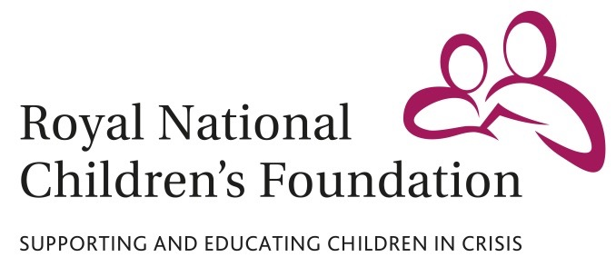

MEDIA RELEASE  
17 March 2016

**Advice you can bank on: Barclays staff attend career planning day for children supported by the RNCF and Reed’s School pupils**

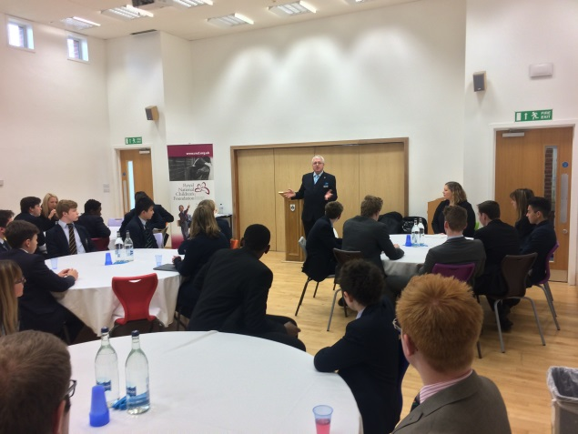

Staff from Barclays attended a special Careers Advice Day for secondary school pupils, including beneficiaries of the Royal National Children’s Foundation (RNCF), held at Reed’s School, Cobham, on Tuesday 15 March 2016.

During a packed day of activities, pupils received expert advice on writing CVs and applying for jobs, and also had their interview skills put to the test by visiting Barclays staff members. Barclays staff also talked about their own working lives and described what their average days working for the banking corporation are like.

Pupils attending the day included beneficiaries from the Royal National Children’s Foundation. Founded in 1827 by Andrew Reed, the charity supports children and young people who are facing abuse, neglect or trauma at home by enabling them to attend boarding schools, such as Reed’s School. The RNCF is based in an office at Reed’s School.

Geoffrey Dennis, Chief Executive of the RNCF, said: “The Careers Advice Day gave beneficiaries of the Royal National Children’s Foundation and Reed’s School pupils an invaluable opportunity to develop their employability and find out more about the jobs market they will be entering in the next few years. Feedback to the day has been extremely positive and we are immensely grateful to all the Barclays staff who attended the event, and to Reed’s School for hosting it.”

Mark Hoskins, Headmaster of Reed’s School, said: “The Careers Advice Day provided Reed’s School pupils the opportunity to contemplate their future career aspirations with the help of employees from one of the world’s biggest companies. It also allowed them to gain a vital insight into many aspects of the working world, from applying for a job to preparing for the interview, to a typical working day. I am sure that all the pupils who took part will have gained an enormous amount from the experience.”

Nicholas Smith, Assistant Manager at Barclays Uxbridge, said: “Barclays were delighted to participate in the Careers Advice Day and help the pupils prepare for their future careers. It was a great way for us to help the local community at Reed’s School and show our support for the incredible work of the Royal National Children’s Foundation.”

Find out more about the Royal National Children’s Foundation and its vital work at www.rncf.org.uk

**For all media enquiries please contact:**

David Bassom

Tel: 07818 865750

Email: [dbassom@rncf.org.uk](mailto:dbassom@rncf.org.uk)

RNCF, Sandy Lane, Cobham, Surrey KT11 2ES

**Notes to Editors**

The Royal National Children’s Foundation (RNCF) is a registered charity that helps children facing abuse, neglect or trauma at home by enabling them to attend state and independent boarding schools and day schools. The RNCF currently supports nearly 400 vulnerable and disadvantaged children. As well as paying school fees, the RNCF also funds counselling, educational school trips and holidays for vulnerable children, many of whom have never had a holiday.

The charity was founded in 1827 by Dr. Andrew Reed, with Queen Victoria as its Patron. Its current patron is the Princess Royal, who plays a very active role in the RNCF.

The RNCF is entirely voluntary funded, and depends on the generosity of supporters to continue its vital work. Registered charity no. 310916.

ENDS