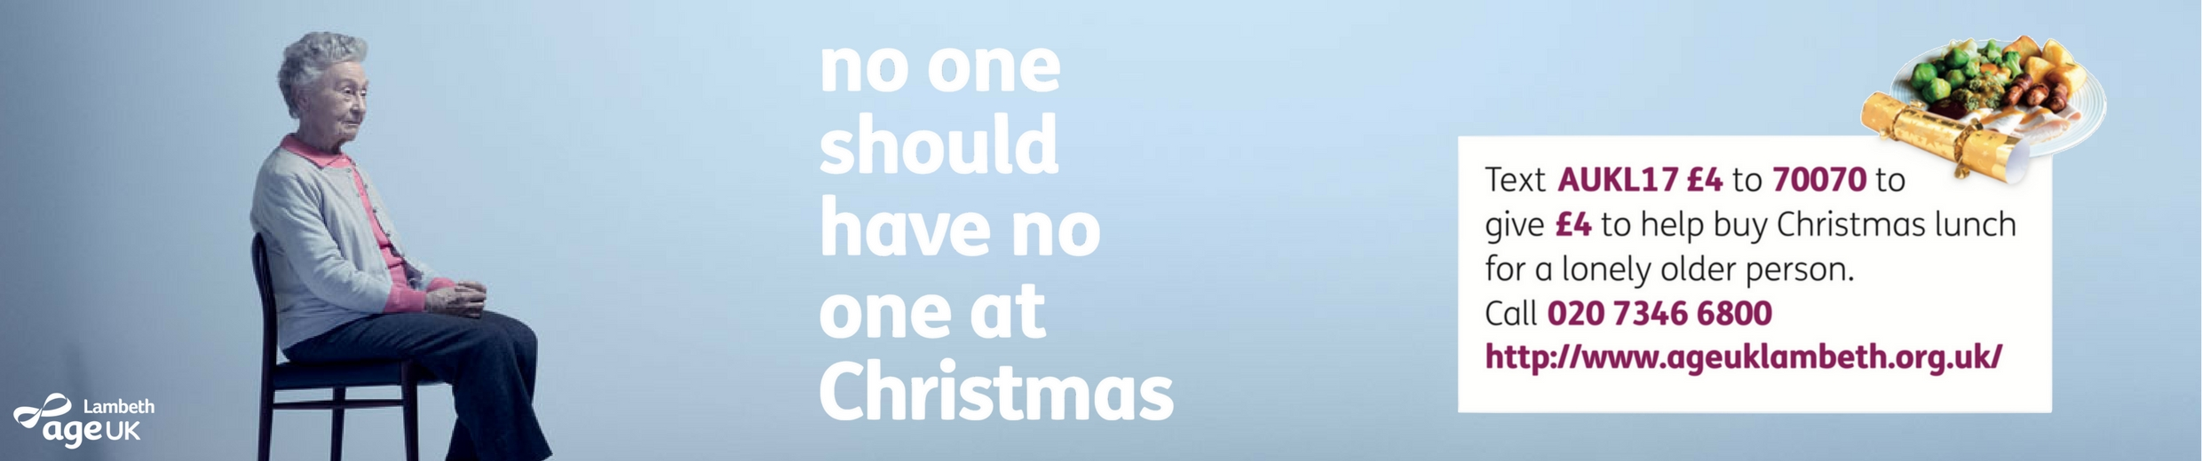
PRESS RELEASE – IMMEDIATE RELEASE

No one should have no one on Christmas Day
Age UK Lambeth needs your support to provide a Christmas Dinner for the most isolated older people

On Christmas Day volunteers from Age UK Lambeth will be cooking up turkey and all the trimmings and providing dinner, gifts and entertainment for 40 of the most socially isolated older people across the borough of Lambeth at their community hub Vida’s. We will also be providing a further 20 meals for those who would prefer to be at home and we need your help to make it happen.
Could you make a donation to provide a Christmas Lunch for a lonely older person?

You can donate any amount online at https://www.justgiving.com/campaigns/charity/auklambeth/nooneshouldhavenoone2017
or
by texting AUKL17 £4 to 70070 to donate £4.

Winter and the festive season can be tough for older people, it gets dark early, the bad weather can make people worried to go out and as so much of the focus in the media is on family time, you can feel especially isolated if you don’t have any family nearby. In fact half a million older people across the UK will spend Christmas Day alone.
- 200,000 older people say they haven't had a conversation with friends or family for a month.
- 3.9 million older people agree the television is their main form of company.
- Loneliness can be as harmful for our health as smoking 15 cigarettes a day.

This year we have the great pleasure to have British actress Miriam Margolyes OBE supporting our Christmas campaign to tackle loneliness for older people in Lambeth!
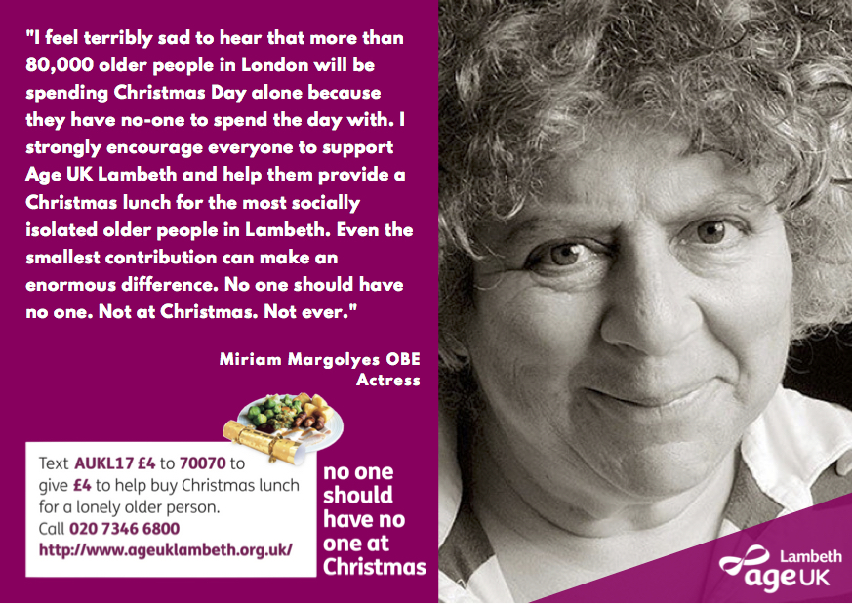
Age UK Lambeth is a local independent charity that supports older people across the entire borough with a range of services to help people stay as independent and active as possible. We want to ensure that the second half of their life is as enjoyable as the first, and we rely on the generosity of the local community and businesses in order to provide our services.
There are also opportunities for businesses and volunteers to get involved with our Christmas Day Dinner. If you are local business who would like to find out about sponsorship opportunities for our No one should have no one campaign then please email Claire.nethersole@ageuklambeth.org.uk If you would like to volunteer please email bev@ageuklambeth.org
The money raised from the campaign will be also used for a Christmas party for our clients and for MySocial. MySocial is our service providing a calendar of fun events all year round for older people to meet new friends, stay active and enjoy their lives.
ENDS

For more information about this press release please contact panagiotis.balalas@ageuklambeth.org.uk

Notes to Editors
Age UK Lambeth supports over 5,000 people every year.
More information about our services can be found at www.ageuklambeth.org.uk
Find Age UK Lambeth on social media Facebook – Twitter - Instagram
As budgets are squeezed and funding becomes more competitive we are increasingly reliant on the kind donations of members of the public and organisations in order to provide our services.
Explore the variety of services we run for older people in Lambeth HERE

