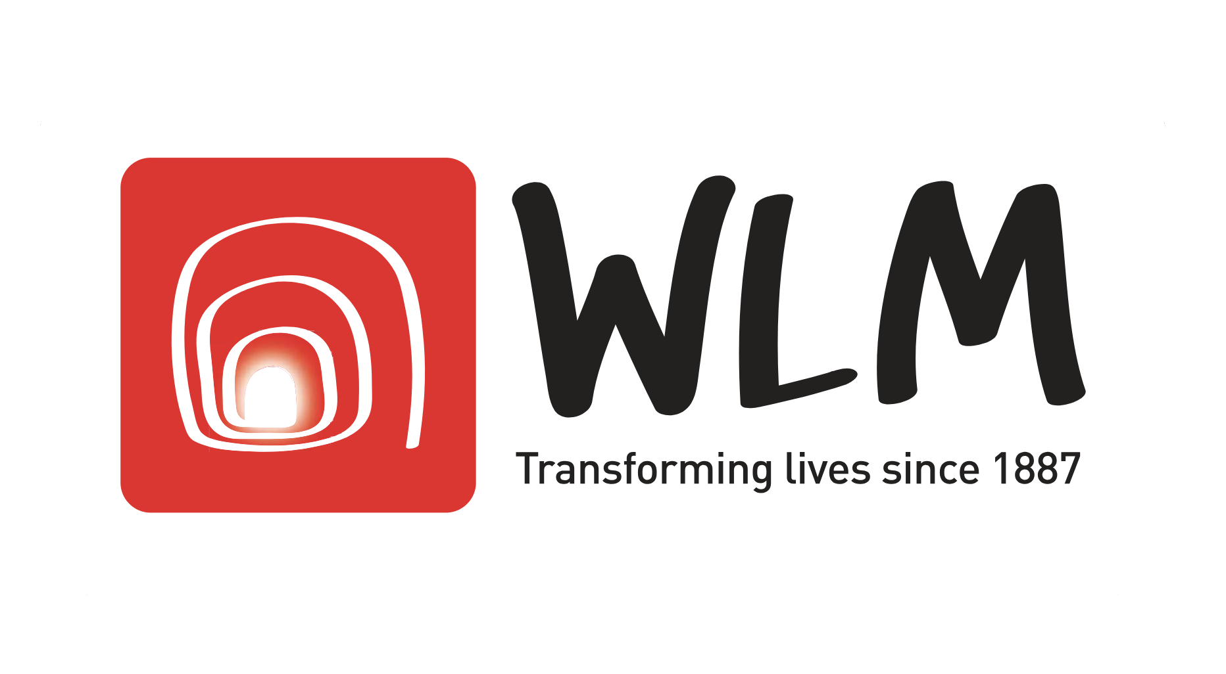

FOR IMMEDIATE RELEASE Date 12/09/2018

WLM’s Sleep Out 2018
Would you sleep out of your comfort zone?

WLM has been helping homeless people for 130 years and is calling for volunteers willing to sleep out for one night to raise awareness and funds for our work. On 26th October, we are looking for 50-60 people willing to brave the cold and Sleep Out so that others don’t have to.

At WLM, we empower people affected by homelessness, poverty and trauma to live more fulfilling lives. Our service at Seymour Place, helps those who are sleeping rough and offers them both immediate respite care and long-term housing solutions. We provide hot breakfasts, showers, laundry, clothing store, haircuts, luggage storage, health care and mail collection as well housing advice service. Last year we helped 249 people off the streets and into safe accommodation. We rely on donations to make sure our vital work can continue as we don’t receive any government funding.

Homelessness continues to be a growing problem. Since 2010, numbers of rough sleepers in London have increased by 170%. One of our clients, Nick, was sleeping rough since 2012 when he decided to leave his property due to domestic abuse by his wife and children and ended up on the streets. When he came to WLM Seymour Place, our project workers did their best to find accommodation and work for him – ‘WLM helped me to find a kitchen porter job and my project worker went with me to the interview. After my two weeks training they hired me. I currently live in the night shelter that WLM co-ordinates, where I have been able to save money for rented accommodation’.

We invite you to join our annual Sleep Out on Friday 26th October and help us support homeless people off the streets, into work, accommodation and onto a better chapter in their lives. WLM's Sleep Out is an opportunity for everyone to be sponsored by their friends, family and contacts, sleeping out for just one night in the secure gardens of St James's Church Piccadilly, so that others don't have to.

Can you help us transform more homeless people’s lives in London this year?

You can find more information about our Sleep Out 2018 on WLM’s website by clicking HERE

Event enquiries: Grace Hunt – WLM Sleep Out coordinator
M: grace.hunt@wlm.org.uk
T: 020 7569 5915
Media enquiries: Panos Balalas – WLM Communications & Marketing Manager
M: panos.balalas@wlm.org.uk
T: 020 7569 5917

West London Mission - Central office: 19 Thayer Street, London, W1U 2QJ. T: 020 7935 6179 - F: 020 7487 3965. Charity Number 1133739 | www.wlm.org.uk

