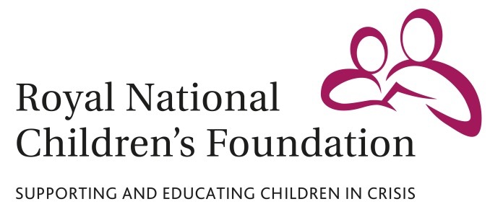

MEDIA RELEASE

12 April 2016

**Shooting star: TV presenter Johnny Ball to attend Clay Pigeon Shoot in aid of children’s charity**

TV presenter Johnny Ball (Think of a Number, Strictly Come Dancing) will be attending a charity clay pigeon shoot in aid of the Royal National Children’s Foundation (RNCF) at the Royal Berkshire Shooting School in Pangbourne on Thursday 5 May.

The Berenberg Charity Clay Pigeon Shoot will put participants’ skills to the test over the course of an action-packed day, with all proceeds going to the charity. All levels of experience are welcome and shooting instructors will be on hand to advise participants as required.

Entry to the event will include breakfast, midday refreshments and a three-course afternoon meal. It will also allow participants to take part in an auction of exclusive prizes, which will be hosted by Johnny Ball.

The charity shoot will be hosted by Berenberg Private Banking in support of the RNCF. The RNCF supports vulnerable and disadvantaged children facing crisis by enabling them to attend state or independent boarding schools, away from the difficulties they face at home.

Johnny Ball said: “I am looking forward to attending Berenberg’s Charity Clay Pigeon Shoot. Whether you’re a seasoned clay pigeon veteran or a first-timer, it’s going to be a great day out.

“The Berenberg Charity Clay Pigeon Shoot is also going to be a great way to support the Royal National Children’s Foundation’s work with vulnerable and disadvantaged children. The charity supports children who are in really desperate situations and has a 189-year-old history of helping children overcome their problems, rebuild their lives and achieve great things.”

Geoffrey Dennis, Chief Executive of the Royal National Children’s Foundation, said: “The Royal National Children’s Foundation is extremely grateful to Berenberg for organising this shoot in aid of the charity’s vital work. We have a number of our corporate supporters already lined up to attend, and we would particularly welcome teams from local businesses on the day, as the day will provide a great team-building experience. ”

Tickets to the Berenberg Clay Pigeon Shoot cost £250 per person, with all funds raised going to the RNCF. For more information or to purchase a ticket, contact the RNCF at info@rncf.org.uk or on 01932 868622.

**For all media enquiries please contact:**

David Bassom

Tel: 07818 865750

Email: [dbassom@rncf.org.uk](mailto:dbassom@rncf.org.uk)

RNCF, Sandy Lane, Cobham, Surrey KT11 2ES

**Notes to Editors**

The Royal National Children’s Foundation (RNCF) is a registered charity that helps children facing abuse, neglect or trauma at home by providing them with the opportunity to move into a supported education environment. The RNCF currently enables nearly 400 vulnerable and disadvantaged children to attend state and independent boarding schools and day schools. As well as paying school fees, the RNCF also funds counselling, educational school trips and holidays for vulnerable children, many of whom have never had a holiday.

The charity was founded in 1827 by Dr. Andrew Reed, with Queen Victoria as its Patron. Its current patron is the HRH Princess Royal, who plays a very active role in the RNCF.

The RNCF is entirely voluntary funded, and depends on the generosity of supporters to continue its vital work. Registered charity no. 310916.

ENDS