*EXCLUSIVE NEW SERIES - UK PREMIERE*

*EASY RIDERS: THE WRONG WAY ROUND*

Premieres Monday 18 January at 9 pm on Sky 539, Virgin 269, Freeview HD 63 and Freesat 651

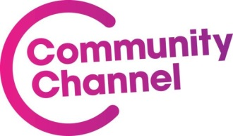

**Community Channel premieres Easy Riders: The Wrong Way Round,**

**a brand new biking adventure series for the Children’s Air Ambulance**

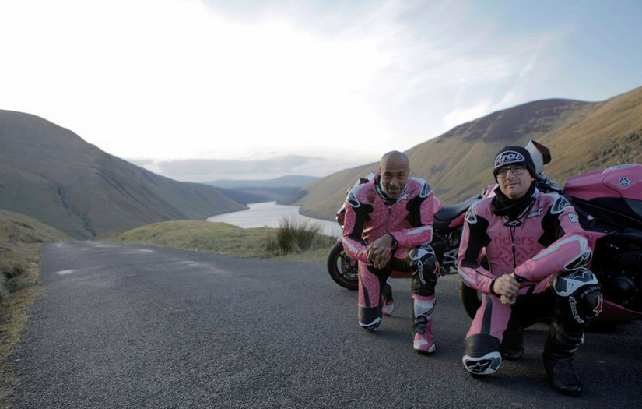

The Easy Riders, Danny John-Jules and Steve Keys, are back as they take on the challenge of biking from London to Brighton but... they've decided to do it the wrong way round!

Join Danny John-Jules (*Red Dwarf*, *Death in Paradise*) and motorcycle entrepreneur Steve Keys as they embark on an epic 1,000-mile adventure from London to Brighton all the way round the UK. The unscripted ‘travelogue for a difference’ sees the big-hearted bikers hit the open road, dressed in custom-made pink leathers on pink Yamaha R1 motorbikes, all in support of the Children’s Air Ambulance charity. Along the way they meet some famous faces including footballing legend enthusiast Ian Wright, TV actress Amanda Mealing and *Quadrophenia* legend Phil Daniels.

*Easy Riders: Wrong Way Round* is a charming, spontaneous and hair-raising half-hour series. Narrated by Chris Barry (*The Brittas Empire*, *Tomb Raider*) The Easy Riders’ take viewers on the ultimate bike ride from London to Leicester up to Scotland and back round to Brighton. Their physical endurance is put to the test as they journey through chills, strong winds and rain, but their wit and camaraderie never falters (at least not for long!)

Although the trip definitely tests their mettle, it’s ultimately great fun. Viewers are given a behind the scenes look at their prep, witness their trials and triumphs, and share in the laugher of an incredible journey for a brilliant cause.

The trio’s mission is to raise awareness of the Children’s Air Ambulance, a charity that flies critically ill children across the UK to the specialist care they need. They know that the longer a sick child is out of hospital, the greater the risk. Their helicopter not only flies fast, but also serves as a flying intensive care unit. They deliver children to safety four times faster than transport by road, and when every second counts this can be a matter of life and death.

Patrick Hurst, Channel Manager on Community Channel, said: “We are delighted to be broadcasting the latest series of *The Easy Riders*, joining Danny and Steve as they raise awareness and funds for a terrific charity and have some misadventures along the way. Blur those nipples!”

Danny John-Jules said: “The trip was tough and really tested our mettle but ultimately it was FUN – it was a bunch of mates on the same level having a laugh!”

Steve Keys said: “We wanted to create the ultimate motorcycle trip, and that’s what we did! But it’s not just about the journey – viewers get a look behind the scenes, showing the prep, the laughs, the setbacks and our shared love of MotoGP!”

*Easy Riders: The Wrong Way Round* was commissioned by Community Channel and is produced by MotoVentures, an independent television company.

The first episode premieres on Monday 18th January at 9pm and follows Danny and Steve as they start their new adventure. Heading for Essex to ride world famous motorcycles they are escorted by Ian Wright, Phil Daniels and a gang of Mods. *Easy Riders: Wrong Way Round* will continue with new episodes the same time each week, for six weeks.

ENDS

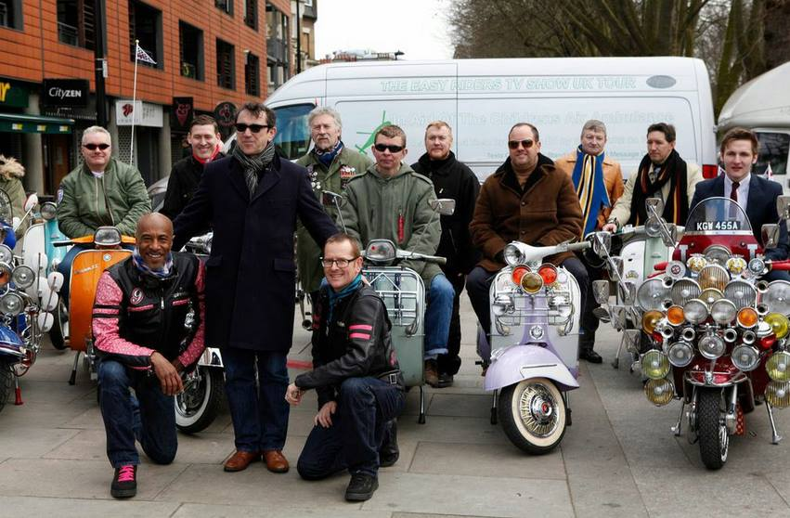

Danny and Steve with Phil Daniels and Quadrophenia fans

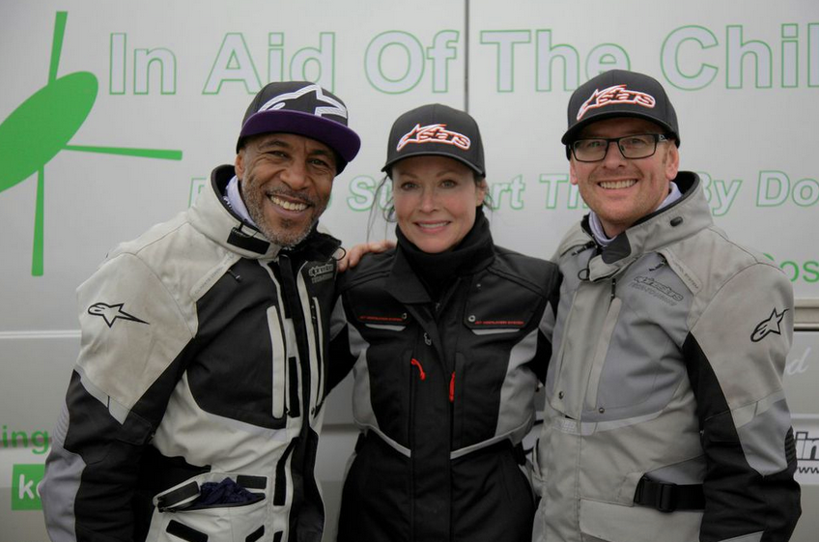

Danny, Amanda and Steve at the Children’s Air Ambulance

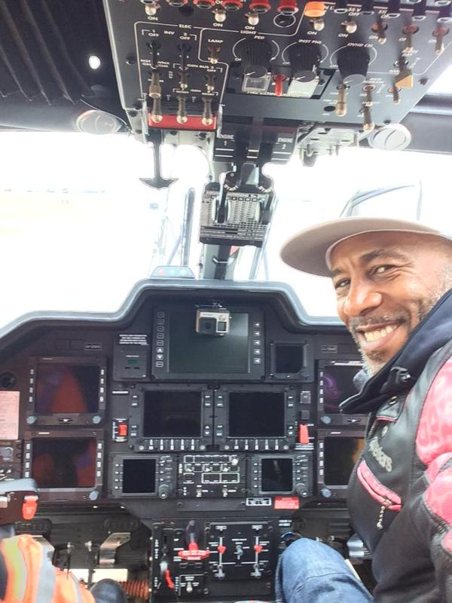

Danny in one of the Children’s Air Ambulance helicopters at Coventry Airport

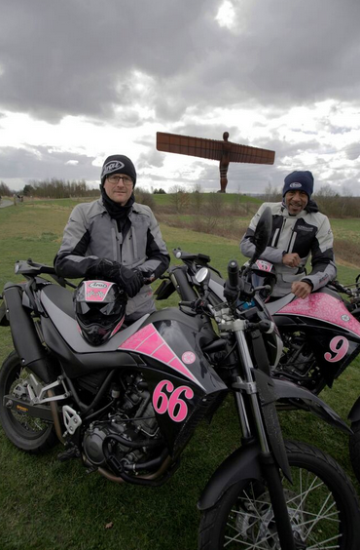

Danny and Steve with the Angel of the North

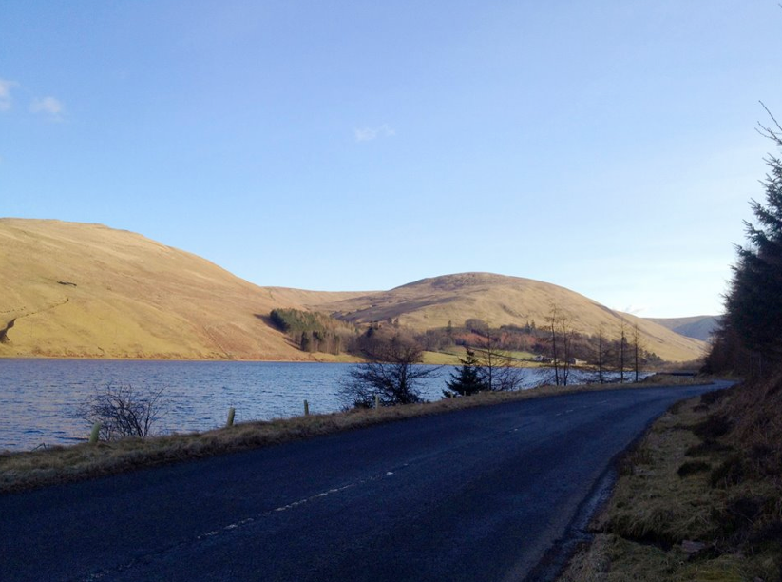

The lush highlands of Scotland – perfect for biking!

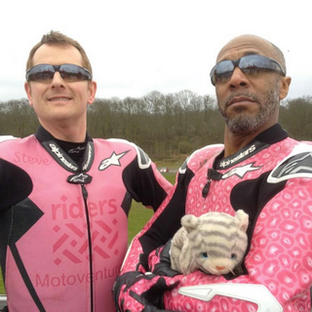

Steve, Danny, Cuddly Toy

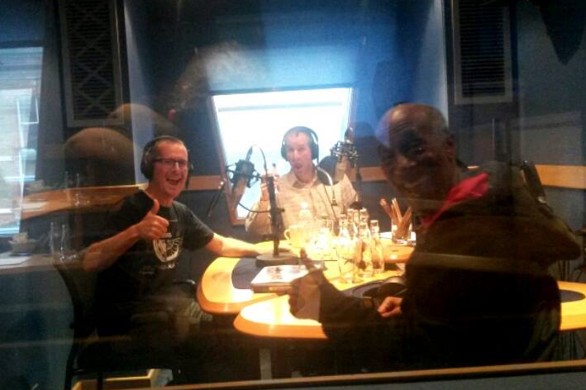

Danny and Steve in the studio with Chris Barrie recording the narration

**THE EASY RIDERS – MEET THE TEAM**

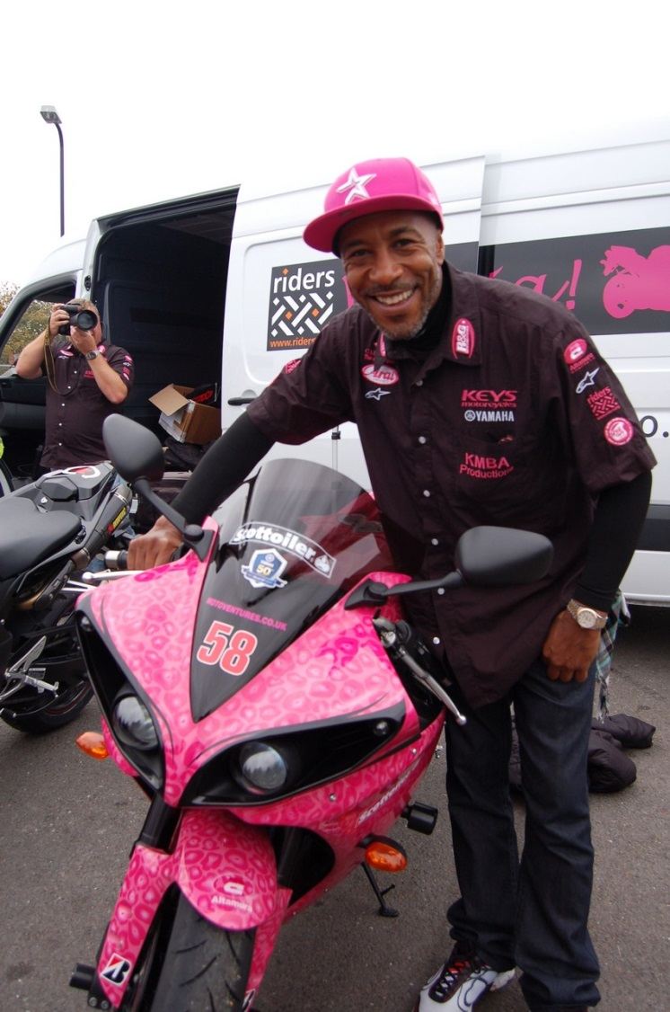

Danny John-Jules - one of Britain's most well-loved TV actors, best known for playing Cat in the sci-fi comedy series *Red Dwarf* and policeman Dwayne Myers in BBC’s *Death In Paradise*.

Danny found a love for motorcycles fifteen years ago when he was invited to watch MotoGP. Thinking it looked cool; Danny bought himself a bike, booked his training and has been hooked ever since.

Danny is currently filming the next two series of *Red Dwarf* and recently completed his first short film, *Bucky*, which will premiere alongside *The Easy Riders: The Wrong Way Round* on Community Channel.

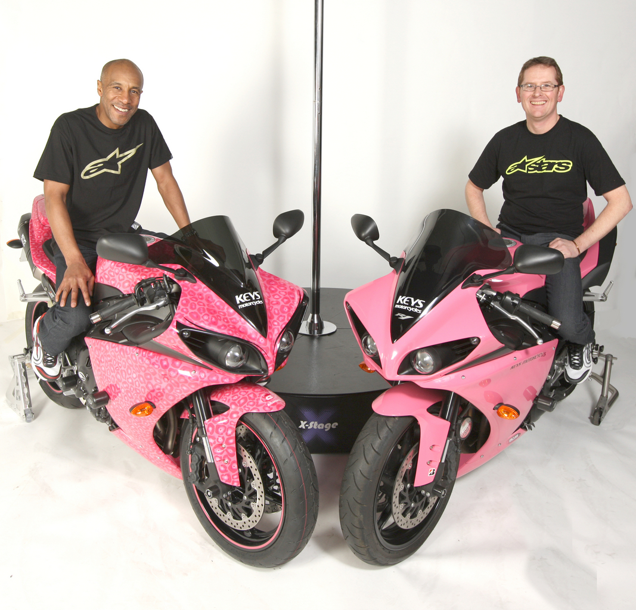

Steve Keys was born into a family of motorcycle racers and began riding at the tender age of 9, before racing professionally by the time he was just 17. Something of an entrepreneur, he now has several businesses including an award-winning motorcycle dealership. As well as undertaking adventure rides, Steve writes for Racer Magazine and has recently appeared in the film *Under the Skin* alongside Scarlett Johansson.

**Notes to Editors:**

**About Community Channel**

Community Channel is the only TV channel for communities, charities and the brilliant people who make the U.K. a better place for us all. Community Channel broadcasts on Freeview HD 63, Sky 539, Virgin 233, freesat 651, streamed on TV Player and TVGuide and available on-demand through BT TV, YouTube, BBC iPlayer and the channel’s website. Twelve million people watched the channel last year. Viewers learn more by watching the channel and are motivated to do more for others. Community Channel is a Media Trust initiative, funded by the Big Lottery Fund. [www.communitychannel.org](http://www.communitychannel.org)

**About Media Trust**

At Media Trust we believe in the power of media to change lives. We work with the media industry to empower charities and communities to have a voice and be heard. This is achieved by:

* Providing communications skills and resources through expert-led training courses and events, free professional support, film production, free online guides and resources;
* Helping access audiences through Community Channel on TV and online, national news distribution and media partnerships;
* Harnessing creative industry talent through media volunteers and media partnerships

We are the UK’s leading communications charity. Our corporate members include A+E Networks, adam&eveDDB, AMV BBDO, Arqiva, BBC, Bloomberg, BT, Camelot, Channel 4, Dentsu Aegis network, Discovery Networks Europe, dmg media, Endemol, ESI Media, Facebook, Global Radio, Google, Guardian Media Group, Havas Media Group, Hearst, IAB, ITN, ITV, Just::Health Communications, MTV Networks UK & Ireland, Next 15, Saatchi & Saatchi, Sky, Starcom MediaVest, telegraph media group, Twitter, Time Warner, Trinity Mirror, Virgin Media, UBM, UKTV, Weber Shandwick, WPP and Yahoo!. [www.mediatrust.org](http://www.mediatrust.org)

**About Big Lottery Fund**

* The Big Lottery Fund supports the aspirations of people who want to make life better for their communities across the UK. We are responsible for giving out 40% of the money raised by the National Lottery and invest over £650 million a year in projects big and small in health, education, environment and charitable purposes
* Since June 2004 we have awarded over £6.5billion to projects that make a difference to people and communities in need, from early years intervention to commemorative travel funding for World War Two veterans
* Since the National Lottery began in 1994, £33 billion has been raised and more than 450,000 grants awarded

Website: www.biglotteryfund.org.uk

Twitter: @biglotteryfund #BigLottery

Facebook: www.facebook.com/BigLotteryFund

For funding and general enquiries call: BIG Advice Line: 0345 4 10 20 30

For press enquiries call: Press Office: 02890 551 432 / Out of hours contact: 07580 811135