PRESS RELEASE
From: Sussex Cancer Fund
Date: 28th April

Acute Oncology Nurse, Katie, Donates Postponed ‘Hen Do’ Payment to Charity
Sadly Covid-19 has meant that a lot of events have had to be postponed or cancelled. This is also the case for Acute Oncology Nurse, Katie Ledger and her Fiancé, Andy. Their wedding should have been taking place in June this year but has been delayed because of the virus. This has also meant that any plans for her ‘Hen Do’ have had to be cancelled, some guests had already prepaid but wanted to donate any money to a charity of Katie’s choice. Katie chose the local Brighton based Sussex Cancer Fund as the beneficiaries of the gift.
Katie said “I have worked in cancer services at Brighton since I was newly qualified in 2011. as a staff nurse, then a junior Sister and most recently Acute Oncology Clinical Nurse Specialist. I’ve now left to work at the Marsden but Brighton will always be home!
The SCF is an important charity to me as it has supported my places of work over the years helping us getting the right equipment for our ward as well as supporting so many of my patients. It’s also important to me to support small local charities.
When my family ‘hen do’ was cancelled, due to my wedding sadly being postponed to next year, my Mum’s cousin wanted me to donate her money from the hen do to a charity of my choice, so I picked SCF as it really is close to my heart.
I have asked for the money to be directed towards courtyard level 8 my old ward, they have supported me endlessly for the last 8 or so years and now in challenging times, they are on the front line of our fight against Covid 19. I hope this token gesture helps just a little.”
Joanna Godden, from the Sussex Cancer Fund commented “ Their wedding should have been this June and is now July 2021. We will look forward to seeing a photo from the Happy Day but in the meantime, thank you, Katie & Andy, with so many of our fundraising events being cancelled this will go a little way to helping us with the shortfall and help us to continue to provide the best possible cancer care to patients in Sussex”.

You can find out about the work of the Sussex Cancer Fund by visiting their website www.sussexcancerfund.co.uk.
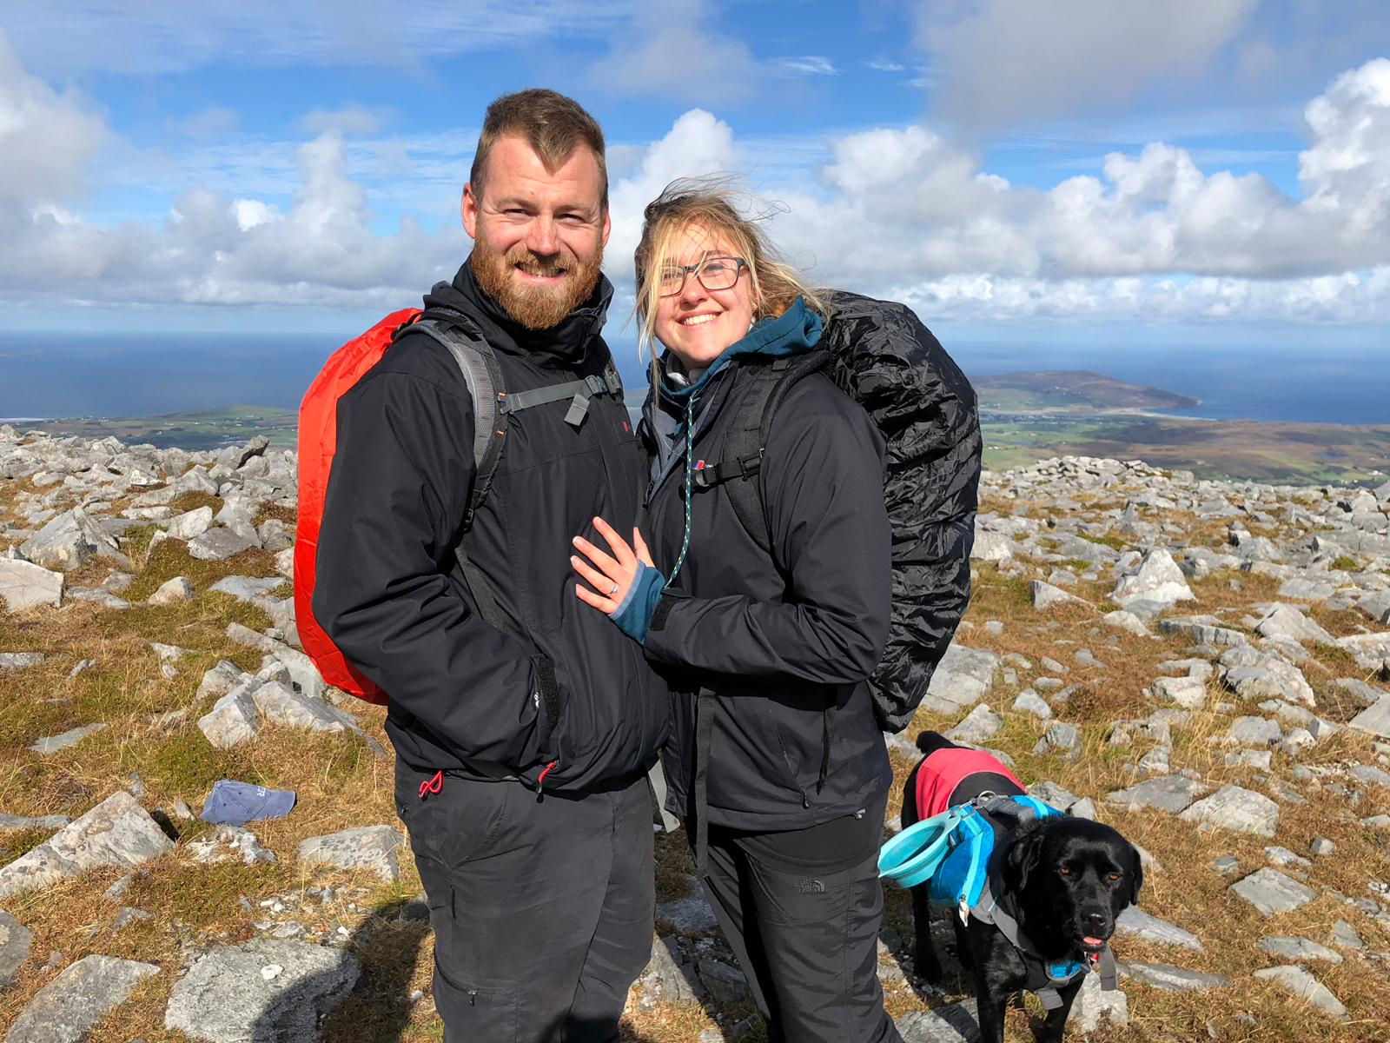

END
Image: The photo shows Katie and Andys engagement at the top of Muckish mountain in Ireland from in September 2018
Contact:
Joanna Godden
Marketing & Communications Officer
Sussex Cancer Fund
Email: joanna.godden1@nhs.net
Tel: 01273 664930
Editors Note:
The Sussex Cancer Fund was created in 1981 by consultant oncologists Dr Deutsch, Dr Hodson and Dr Murrell. The goals of the fund are to work hand in hand with the NHS to give every cancer patient in Sussex the best available treatment and facilities.
Our most recent success included over £1 million worth of refurbishment to patient areas at the Sussex Cancer Centre including:
- A comfortable patients’ lounge
- A more accessible entrance and reception
- Up to date Impression Suite and the latest immobilisation system
- The North extension released offices to provide vital clinical space
- The patient and carers’ car park
- Refurbished quiet room
- Refurbished chemotherapy waiting room
- Recipe books for chemotherapy patients
- Accessible garden – providing a relaxing, outdoor space to aid the support to cancer patients and their families

