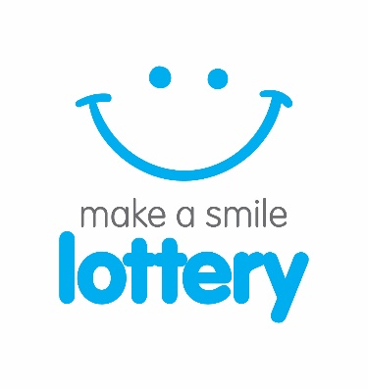 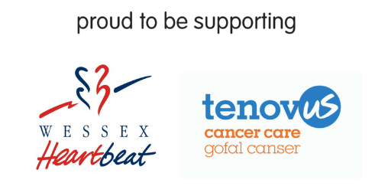PRESS RELEASE
17th October 2017
Lottery team at St Helena Hospice celebrate successfully launching their first draw to help other charities!

The very first lottery draw for St Helena Hospice’s new venture ‘make a smile lottery’, took place on Friday 13th October 2017 creating its first cash prize winners!
The Colchester-based charity already runs the very successful Your Hospice Lottery, working with nine other hospices up and down the country. The weekly hospice lottery draw has raised over £8 million for hospice care since 2001.
Building on the success of Your Hospice Lottery, the team at St Helena Hospice have ventured outside of the hospice world and launched ‘make a smile lottery to support local charities like Wessex Heartbeat and Tenovus Cancer Care, with more to follow. This is will be a vital new income stream for the hospice, with them receiving a small admin fee from every £1 played.
The all new lottery draw is going to prove popular with charities all over the Great Britain who simply can’t afford to have a lottery operation in house, and don’t have all the knowledge required to run this kind of operation.
Entry into the draw costs £1 per week, and players have the chance to win one of 16 guaranteed weekly prizes, including a top prize of £250 and a further 15 £10 prizes. There will also be a rollover jackpot which if not won increases by £200 each week up to a maximum of £10,000! The prize fund will be reviewed regularly and as more people join the draw, the prizes will increase.
Alex Howe, Head of Lottery at make a smile lottery commented “We are very excited to be launching this new lottery product, which will bring St Helena Hospice more income, and at the same time we are working with some amazing charities, helping them generate the income they need. We are one of the most experienced charity lottery providers in Great Britain, based in Colchester and we are using our skills and expertise to branch out and create new lottery products”

He went on to say “For each £1 played in the lottery, St Helena receives a small administration fee, with the players chosen charity receiving a large percentage, with the rest going towards the essential costs of running the draw and the prize fund. By working together in this way, we are able to give more money to the charity than most other lottery operations out there, along with highest level of customer service”

Mark Jarman-Howe Chief Executive of St Helena Hospice commented “We are delighted to have the first draw of make a smile lottery, our first partners being Tenovus Cancer Care and Wessex Heartbeat. This is a great new venture lead by St Helena Hospice working with a range of charities across the country, raising much needed funds for good causes in communities just like yours”

To join the lottery in support of your chosen charity:
Visit www.makeasmilelottery.org.uk or telephone the lottery office on 0300 303 4500

If you are a charity thinking of starting a lottery or replacing your existing provider contact us, we can increase your income from your lottery operation:
Visit www.makeasmilelottery.org.uk or telephone the lottery office on 0300 303 4500

Photos: see attached
‘The very first draw day’ at the make a smile lottery office, Phoenix Square, Wyncolls Road, CO4 9PE

For further press information contact:
Sally Thomas, Marketing Manager, make a smile & your hospice lottery, sally@makeasmilelottery.org.uk or 0300 303 4500

About make a smile lottery
make a smile lottery exists only to raise funds for local charities, is owned and run by St Helena Hospice who receives a small income towards hospice care from each membership for administering the lottery. It costs just £1 per week to play and lottery members are making a difference to people in their local community who benefit from the fantastic local causes that make a smile lottery supports. By working with local causes in this way rather than setting up their own lotteries, overheads and costs are kept to a minimum so more funds can be used for charitable purposes. Members choose which local cause they wish to support with their membership. After running costs and the prize fund are taken out, the rest of every £1 goes directly to support your chosen cause and the fantastic work they do in the community. A team of fundraisers representing make a smile lottery, ask members of the community to play the lottery in support of their chosen charity, and they are paid to do so from a small budget specifically allocated for this purpose. Make a smile lottery is regulated and licensed by the Gambling Commission (number 000-004685-N-306842-006) under the Gambling Act 2005. Lottery members must be 16 or over and a full set of terms and conditions are available online at www.makeasmilelottery.org.uk or from the make a smile lottery office by telephone 0300 303 4500.

