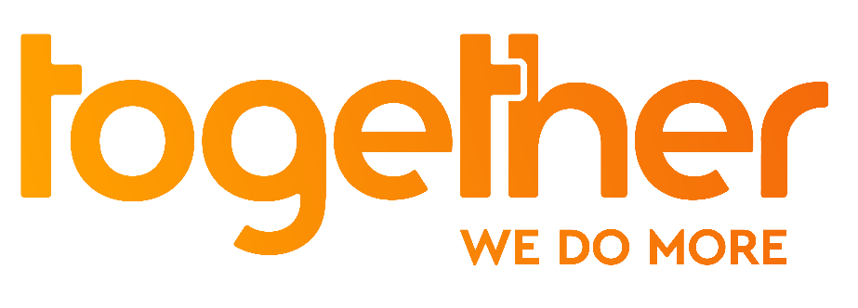

For immediate release

Anthony Bourdain, one month after:
TV series ‘No Reservations’ is back to support who struggles with life

Watch the trailer>>
Pictures and stills available here>>

London 8th July 2018 - One month after he sadly died by suicide, Together wants to commemorate the work of Chef and Broadcaster Anthony Bourdain by showing a curated selection of episodes from ‘Anthony Bourdain: No Reservations’.

In his most celebrated TV series, Anthony Bourdain visits overseas countries and cities worldwide, where hosts treat him to local culture and cuisine. Together will broadcast the most adventurous episodes, filmed around the world: India, Korea, Ghana and Sweden.

The tribute will be on air on Sunday the 8th from 2pm onwards on Together.

After the show details will be given of Samaritans’ helpline. People can contact Samaritans for free from any phone on 116 123, or email: jo@samaritans.org or visit www.samaritans.org to find details of your nearest branch to speak with someone face-to-face.

Alexander Kann, Chief Executive of Together said: “We were shocked by Anthony Bourdain’s sudden and sad death, and have been moved to bring back No Reservations to mark his passing and help people in a similar place get the help they need. Hopefully his passion for food and culture will still shine through and be an inspiration to those struggle coping with life to get the support they need. The aim of our TV channel is to bring people together and inspire them to do more in their lives as well as in the lives of others. We don’t want anyone to feel isolated and alone, and that by doing this we can help.”

ENDS

For further information, photos, videos or an interview with a spokesperson, please contact:

Francesca Aita
Marketing Manager, Together
francesca@togethertv.com
07482 251 330

Notes to Editors

About Together
Together is the ‘do more’ TV channel. Optimistic, encouraging and celebrating the quirks of British life, we motivate viewers to do more for themselves and those around them through smartly-entertaining series and motivating documentaries.

Available 24-hours-a-day, our programming is geared around wellbeing (Better Together), creativity (Make Together) and community (Get Together).

Together broadcasts 24-hours on Freeview 93, Sky 173, Virgin 269 and Freesat 164, and available streamed and on-demand through www.togethertv.com, TVPlayer, DailyMotion, YouTube, Facebook and BT TV.

Together is owned by over two hundred individual shareholders with a wider group of donors and backers including Sky, Big Lottery Fund, Barrow Cadbury Trust, Channel 4, ITV, BBC, Unltd and Social Investment Business

Together’s launch has been supported by gifted media inventory from companies in the public service broadcasting, channel groups, newspaper groups and tech giants.

To receive Together on Freeview, viewers will need to be within coverage and be watching through Freeview HD or Freeview Play devices. Some viewers may need to retune. Viewers can check predicted coverage at: www.freeview.co.uk/channels-at-your-address

www.togethertv.com

ENDS

