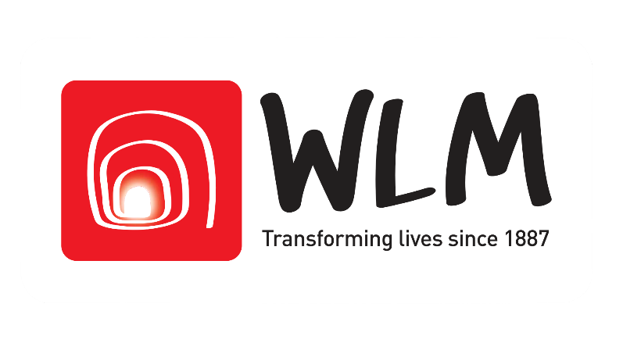

FOR IMMEDIATE RELEASE Date 31/10/2018

Mayor of London gives fundraising boost
to WLM Seymour Place’s transformation
WLM Seymour Place empowers homeless people to rebuild their lives

The Mayor of London has recognised Seymour Place Community Hub project as one of London's best civic initiatives of 2018, with a fundraising pledge of £32,500 through his Crowdfund London initiative.

WLM Seymour Place supports 100 homeless people every day. The number of rough sleepers has increased by 169% in the past 8 years, so our work is needed now more than ever. Real support takes time and space, and this is what WLM Seymour Place provides. In the mornings, we give a mixture of short and long-term help including food, showers, clothing, and access to NHS facilities. We help our clients to rebuild confidence, nurture their skills, and support them into work and stable secure accommodation.

For the rest of the day, our building is underused when it could be serving the local community. We want to engage the community by making the space more inclusive and accessible, hiring rooms to local groups and business. We will have a pop-up restaurant in our café, a temperance bar, events that celebrate Seymour Place's heritage and art exhibitions. We will future proof the space and make it a vibrant, creative space for the whole area rather than separating homeless people from their local community.

The Mayor’s pledge takes us half way to our target of £69,784. We still have a way to go until the 17 December deadline so please do pledge to our Community Hub, talk to your friends and family about this project, and share it widely on social media. Pledges are only charged if the project hits its funding goal by 17 December 2018.

This crowdfund will cover the first stage of our incredible transformation – the feasibility study and concept design stage. From there we will be able to unlock capital funding from heritage funds and larger grant giving organisations.

Help us restore our building and celebrate its heritage; for both the homeless people we support and for the whole community in Marylebone to enjoy!

You can also keep up to date with our crowdfund by following West London Mission on Twitter, Facebook and Instagram.

Project enquiries: Martha Awojobi – Corporate Development Officer
M: martha.awojobi@wlm.org.uk
T: 020 7569 5914

West London Mission - Central office: 19 Thayer Street, London, W1U 2QJ. T: 020 7935 6179 - F: 020 7487 3965. Charity Number 1133739 | www.wlm.org.uk

