FOR IMMEDIATE RELEASE

Legendary cricket umpire and commentator Dickie Bird OBE has donated £30,000 to Children’s Heart Surgery Fund (CHSF), and become their new ambassador

CHSF is honoured to announce legendary cricket umpire and commentator Dickie Bird OBE as their new charity ambassador. What’s more, Dickie has donated £30,000 of his own money to the fund.

CHSF’s CEO Sharon Coyle said:

“We’re beyond thrilled that Dickie Bird – a true Yorkshireman and sporting icon - is becoming our ambassador. Dickie visited the children’s cardiac ward, and his heartfelt engagement with young patients and their families was inspiring to see - it gave them a huge boost.”

“His generous donation, and influence in our region as ambassador, will be felt by generations to come in our continued mission to support hearts for life.”

A press call took place on Thursday, November 16th on the children's cardiac ward at Leeds General Infirmary where Dickie met patients and staff.

Dickie Bird adds:

"To see these youngsters and babies it's given me a lump in my throat and a tear in my eye."

“I’m delighted to help Children’s Heart Surgery Fund and the Leeds Congenital Heart Unit with my donation, and feel privileged to become their ambassador.”

CHSF supports patients born with heart disease and their families throughout Yorkshire by funding the ground-breaking work of the Leeds Congenital Heart Unit. The charity is wholly self-funded by donations from local supporters who help fund life-saving equipment, accommodation for visiting parents, clinical research, ward facilities and key staffing positions.

As an umpire, Dickie was known for adding to the enjoyment of the spectators without ever detracting from the cricket. Since retiring, he has become a media personality, appearing on numerous TV shows and penning the best-selling sports book of all time - My Autobiography. His latest role as charity ambassador, promises to be a very worthwhile partnership for both Dickie and CHSF - itself a celebrated regional institution due to celebrate 30 years as a charity in 2018.

- ENDS –

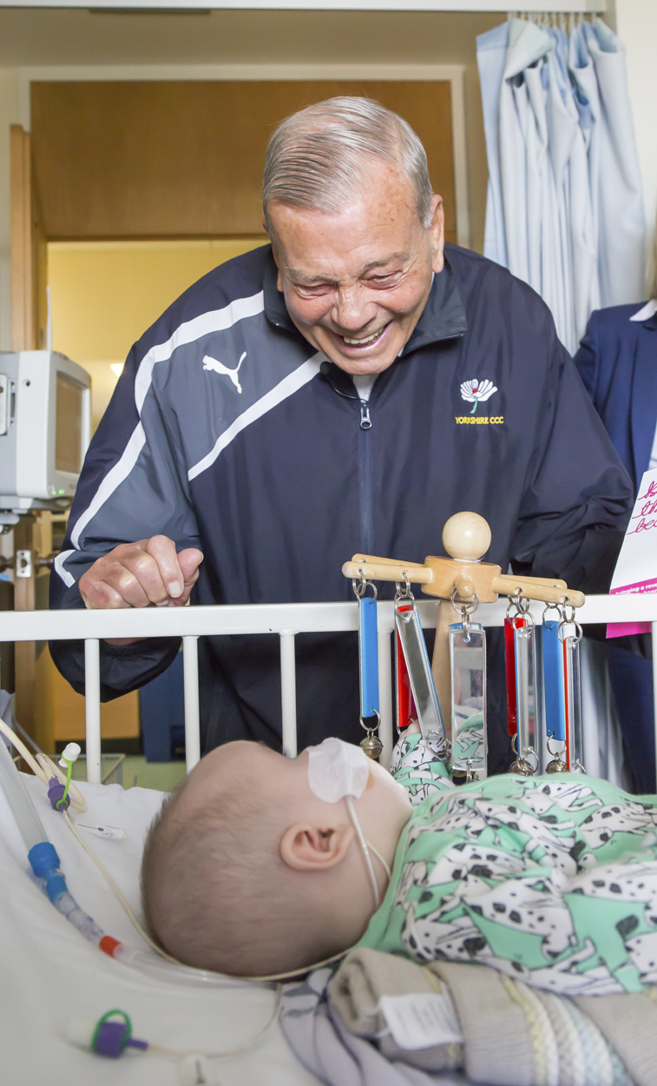
Key facts about Dickie Bird

- Born in 1933 in Barnsley
- Played for Yorkshire and Leicestershire between 1956 and 1964, scoring 3,314 runs in 94 matches
- Made his debut as a Test Umpire in July 1973, overseeing England v New Zealand at Headingley
- Umpired 92 One-Day Internationals and 3 World Cup Finals
- Retired from umpiring in 1996 after officiating 66 Test matches
- Received an MBE in 1986 and awarded OBE for services to the sport and to charity in 2011
- Has received 4 doctorates from Universities including Leeds, Huddersfield, Sheffield Hallam and Bradford
- Appointed president of Yorkshire County Cricket Club 2014-2015
- Was Voted Yorkshireman of the Year at the Yorkshire Awards in 1996, and won a Lifetime Achievement Award at the same event earlier this year

About Children’s Heart Surgery Fund (CHSF)
CHSF is a charity providing support for babies, children and adults born with Congenital Heart Defects in our region. Patients are treated at Leeds Congenital Heart Unit, Leeds General Infirmary, and come from all areas of Yorkshire, Humberside and North Lincolnshire.

CHSF provides valuable equipment, resources and research, as well as providing a support service for both the children and their families along the way. For more information on CHSF, see www.chsf.org.uk.

Editor’s note: To find out more, please call the CHSF’s Marketing Manager Andy McNally on 0113 392 2948 (office) or 07974 978692 (mobile).

