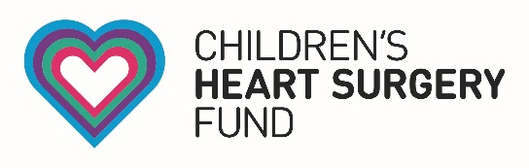

Children’s Heart Surgery Fund
Brotherton Wing, Leeds General Infirmary
Leeds, LS1 3EX
Enquiries: Andy.Mcnally@chsf.org.uk

PRESS RELEASE:

Leeds Congenital Heart Unit to stay open, according to NHS England

The Leeds Congenital Heart Unit has been given the official green light to stay open, according to an update provided by NHS England (NHSE).

NHSE today confirmed it is satisfied with the progress of the Leeds Teaching Hospitals NHS Trust (LTHT) in meeting standards for congenital heart disease services introduced in 2016.

The news has been warmly welcomed by Children’s Heart Surgery Fund (CHSF), who were instrumental in keeping the Unit open in 2013 through the successful Save our Surgery campaign.

Thanks to generous donations for almost three decades, CHSF will be celebrating its 30th anniversary of supporting patients and their families in 2018.

Sharon Coyle, CEO of CHSF said:

“We are thrilled to hear today’s news. Finally, the families of the Yorkshire and Humber region have certainty, I’d like to thank all those who campaigned tirelessly to retain Yorkshire’s only Heart Unit.”

“Without the ongoing support of our families, patients, community, MPs, councillors, corporate partners and the great Yorkshire and North Lincolnshire public, we wouldn’t be open today.”

“We must now look to the future, our aim is to carry on supporting the Heart Unit in reaching the new standards set out by NHSE.”

And LTHT Chief Executive Julian Hartley said:

“This news is very welcome - we are delighted that we can now confirm our ongoing status as a provider of this vital service.”

“I would like to extend my deepest gratitude to our staff at the Leeds congenital heart surgery unit: they have continued to provide world class treatment and care for our patients throughout.”

“I’d also like to thank our supporters and advocates, particularly the Children’s Heart Surgery Fund, who have helped us to reach this point.”

CHSF will celebrate their 30th anniversary as a charity in 2018, and are currently raising funds for a new children’s heart theatre in their Keeping the Beat appeal.

-ENDS-
Notes to editor

For all press enquiries, contact Communications and Marketing Manager Andy McNally on andy.mcnally@chsf.org.uk or call 0113 3922948.

For more information on Keeping The Beat:
www.chsf.org.uk/keeping-the-beat

About Children’s Heart Surgery Fund (CHSF)
CHSF supports children and adults born with congenital heart disease across Yorkshire and North Lincolnshire and works alongside the Leeds Congenital Heart Unit at Leeds General Infirmary. CHSF supports a variety of projects, funding cutting-edge equipment, family accommodation and support, ward facilities, research and staff training.
www.chsf,.org.uk

