PRESS RELEASE
From: Sussex Cancer Fund
Date: 11th May 2020

Sussex Cancer Fund Appeals for Food Donations for Cancer Patients
The Sussex Cancer Fund is appealing to their supporters for donations of food for Cancer Patients in response to the Covid-19 crisis. Mhairi Donald, Consultant Dietitian (You can read more about Mhairi here https://www.sussexcancerfund.co.uk/spotlight-on-staff-mhairi-donald-consultant-dietitian/) has been co-ordinating a Food Bank project which has been receiving kind donations of food and then distributing them to cancer patients in need. Also part of the project is the Brighton College Parent Support Group, who have been gathering up and providing supplies since cancer patients needed to self-shield and have been instrumental in making this project work. Fare Share Sussex has also been dropping off supplies on a weekly basis.
The project has been operating from the Macmillan Horizon Centre (https://www.sussexcancerfund.co.uk/horizon-centre/), a joint project between the Sussex Cancer Fund, Macmillan Cancer Care and the Brighton & Sussex University Hospital Trust.
Mhairi commented, “We have been getting a great supply of foods for our foodbank but we have found some gaps and are looking for some specific items that will be good for cancer patients undergoing treatment.”
They are particularly looking for
- Dried milk powder,
- Milkshake powder like Nesquick,
- Long-life ready to drink milkshakes, like Weetabix On The Go and Ready Brek,

These items are especially good for head and neck and oesophageal cancer patients who are struggling with swallowing
Any donations should be dropped off at the Horizon Centre Café and please adhere to the social distancing rules.

We would like to say a massive thank you to all those that have donated so far, the Macmillan Horizon Centre for the use of their Café, Sarah Back, Cancer Nurse Specialist, Fare Share, the Brighton College Parent Support Group and of course the wonderful Mhairi and all the other staff who have been lending a hand.
END
Image: Mhairi Donald, Consultant Dietitian & Sarah Back, Cancer Nurse Specialist
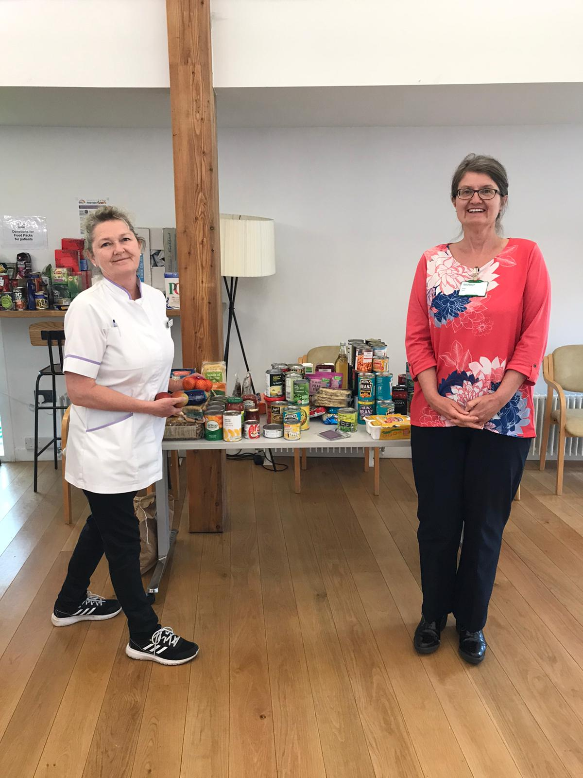
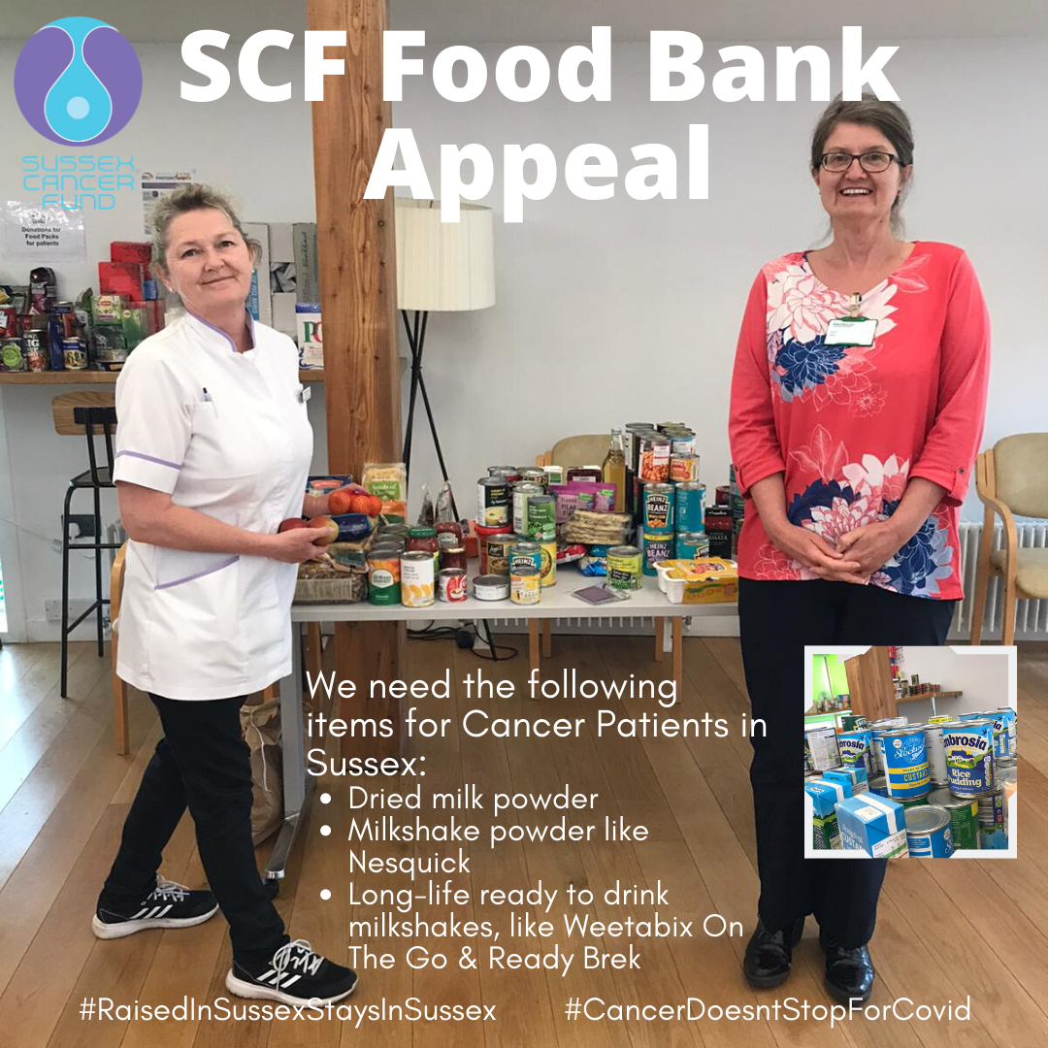

Contact:
Joanna Godden
Marketing & Communications Officer
Sussex Cancer Fund
Email: joanna.godden1@nhs.net
Tel: 01273 664930
Editors Note:
The Sussex Cancer Fund was created in 1981 by consultant oncologists Dr Deutsch, Dr Hodson and Dr Murrell. The goals of the fund are to work hand in hand with the NHS to give every cancer patient in Sussex the best available treatment and facilities.
Our most recent success included over £1 million worth of refurbishment to patient areas at the Sussex Cancer Centre including:
- A comfortable patients’ lounge
- A more accessible entrance and reception
- Up to date Impression Suite and the latest immobilisation system
- The North extension released offices to provide vital clinical space
- The patient and carers’ car park
- Refurbished quiet room
- Refurbished chemotherapy waiting room
- Recipe books for chemotherapy patients
- Accessible garden – providing a relaxing, outdoor space to aid the support to cancer patients and their families

