Crowdfunding raises $31M for energy access

London, England — 1 billion people globally live without access to clean, affordable energy. With no access to the national grid, unserved communities are turning to off-grid energy companies to meet their energy needs. As a result, over 130 million solar home systems and lanterns have been sold since 2010. But with little support from local commercial banks, these off-grid energy companies can struggle to secure appropriate levels of finance to help them to grow sufficiently and to meet increasing customer demand.

Frustrated by the limited finance available in local markets from conventional sources, off-grid energy companies are turning to the crowd to raise much needed debt finance. Last year alone, over $31 million was raised from the crowd to provide clean energy solutions to off-grid communities in sub-Saharan Africa and South Asia, up from $11 million in 2017. New research by Energy 4 Impact reveals that over 90% of crowd-sourced funds for energy access in 2018, were raised on peer-to-peer (P2P) lending platforms.

According to the report this growth has been driven by demand for impact investment opportunities from crowd-investors in the UK, Europe and Japan. Investors are motivated by the prospects of mitigating climate change and reducing energy poverty, while earning a relatively high rate of return (platforms offer annual returns of 4% to 8% on GBP and EUR denominated investments).

UK-based companies BBOXX ($7.3 million) and Azuri Technologies ($1.9 million), supported through UK aid, are two examples of off-grid energy companies that successfully raised debt from the crowd in 2018. Pay as you go (PAYGO) energy companies require significant debt facilities, as their customers pay off their solar home systems over 1 to 3 year terms. Companies are drawn to P2P lending due to its flexibility, cost effectiveness and speed.

CEO of Azuri Technologies, Simon Bransfield-Garth, commented, “The faster you grow the more cash you’ve got tied up in the hands of customers... so being able to access affordable finance is essential to enable us to grow."

The analysis showed that two-thirds of debt financing raised in 2018 was on Sweden-based platform, TRINE, and UK-based platform, Energise Africa. Growth rates are expected to climb further through 2019. Co-author of the Energy 4 Impact report Crowdfunding & P2P Lending for Energy Access – State of the Market 2018, and researcher at the Cambridge Centre for Alternative Finance at Cambridge Judge Business School, Davinia Cogan, said: “The growth of P2P lending was largely unprecedented, with a 10-fold increase in four years. Our analysis shows that P2P lending platforms are now an important source of debt for many off-grid energy companies.”

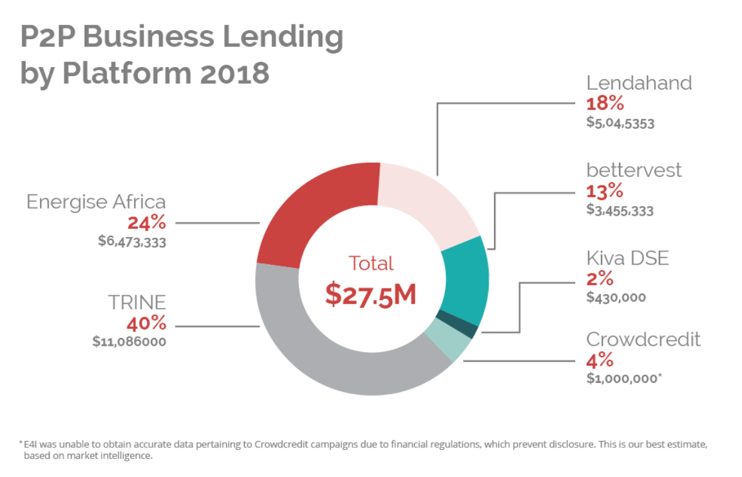
Energy 4 Impact’s report is part of a UK aid-funded initiative, Crowd Power, designed to research innovative technology-driven financing solutions to drive clean energy access in sub-Saharan Africa and South Asia. Crowd Power is funded through the UK Government’s Transforming Energy Access (TEA) programme.

The report also finds that donation crowdfunding for off-grid communities, via philanthropic platforms like UK and USA-based GlobalGiving, is growing steadily at around 45% each year - but the total amount raised is less than $1 million a year. The amount raised for energy access on platforms that offer rewards to campaign-backers, such as Indiegogo and Kickstarter, is falling however, and there were no successful equity crowdfunding campaigns in 2018. Interestingly, the report also captures data on the burgeoning initial coin offering (ICO) market and finds that within this market $1.6 million was raised by two energy access related ICOs in 2018.

Crowdfunding & P2P Lending for Energy Access – State of the Market 2018 is the first in a series of three annual reports over the course of the three-year UK aid funded Crowd Power programme. Later this year, Energy 4 Impact will publish a study on the feasibility of equity crowdfunding for energy access companies. Earlier research papers can be found below.

Powering the crowd into the future
Who is the crowd?
Success & failure: the key to a winning campaign
Can the crowd close the financing gap?
Mapping the market for energy access

About Transforming Energy Access
The Transforming Energy Access programme is supporting the development of innovative technologies, business models, partnerships and skills that will accelerate access to affordable, clean energy services for households and enterprises in developing countries. UK aid is providing up to £100 million ($130 million) through the TEA programme until 2024. To date the programme has already helped people and businesses across Africa cut 2 million tonnes of carbon emissions and improve the lives of 3.2 million low-income people. It has also leveraged $359 million worth of investment in clean energy from the public and private sectors.

NOTES TO THE EDITORS

About Crowd Power
Crowd Power is a research-led programme designed to explore the role of innovative technology-driven financing solutions, such as P2P lending and crowdfunding, in the energy access sector. The programme seeks to understand the impact of innovative forms of capital raising on energy access companies, and the appetite of investors in low, middle and high-income countries for investment opportunities with environmental and social returns.

Crowd Power began in 2015, as a pioneering research programme that examined the role of crowdfunding and P2P lending in the financing of energy access companies and projects. Crowd Power has played an instrumental role in the growth of P2P lending and crowdfunding for energy access businesses, and supported over 250 energy-access campaigns to raise £3.4 million ($4.53 million) in funding.

The second phase of Crowd Power began in 2018, with funding through the UK Government’s Transforming Energy Access (TEA) programme, and seeks to continue research into crowdfunding and P2P lending, while supporting energy access companies to raise pre-seed, seed and growth-phase capital. The programme will also support P2P business lending platforms, by assisting with the set-up costs of capital guarantees and local currency lending facilities, and through investor outreach.

About Energy 4 Impact
Energy 4 Impact is a non-profit organisation which seeks to alleviate poverty in sub-Saharan Africa through accelerated access to sustainable, renewable energy. Supported by a small head office in London, Energy 4 Impact operates from regional offices in Kenya, Tanzania, Rwanda, and Senegal. Energy 4 Impact support the development and growth of privately owned micro, small and medium-sized enterprises which deliver renewable energy products and services to the poor, mainly in rural, off-grid areas. It does so by advising businesses on commercial, financial and engineering matters, helping them to secure the resources they require, and running pilots on new products, business models and expansion into new markets. For more information, please visit https://www.energy4impact.org.

