

**MEDIA RELEASE**

**5 April 2016**

**Fly-on-the-wall children’s series resumes its   
“game-changing” portrayal of modern family life**

* **Series 2 of Our Family premieres on CBeebies from Monday 11 April**
* **New series of 20x11-minute episodes airs weekdays, 5.20pm**
* **Series praised for its pioneering portrayal of family life from children’s perspective and its inclusive portrayal of diverse children**
* **Our Family has been a regular top 10 hit for CBeebies since its debut in February**

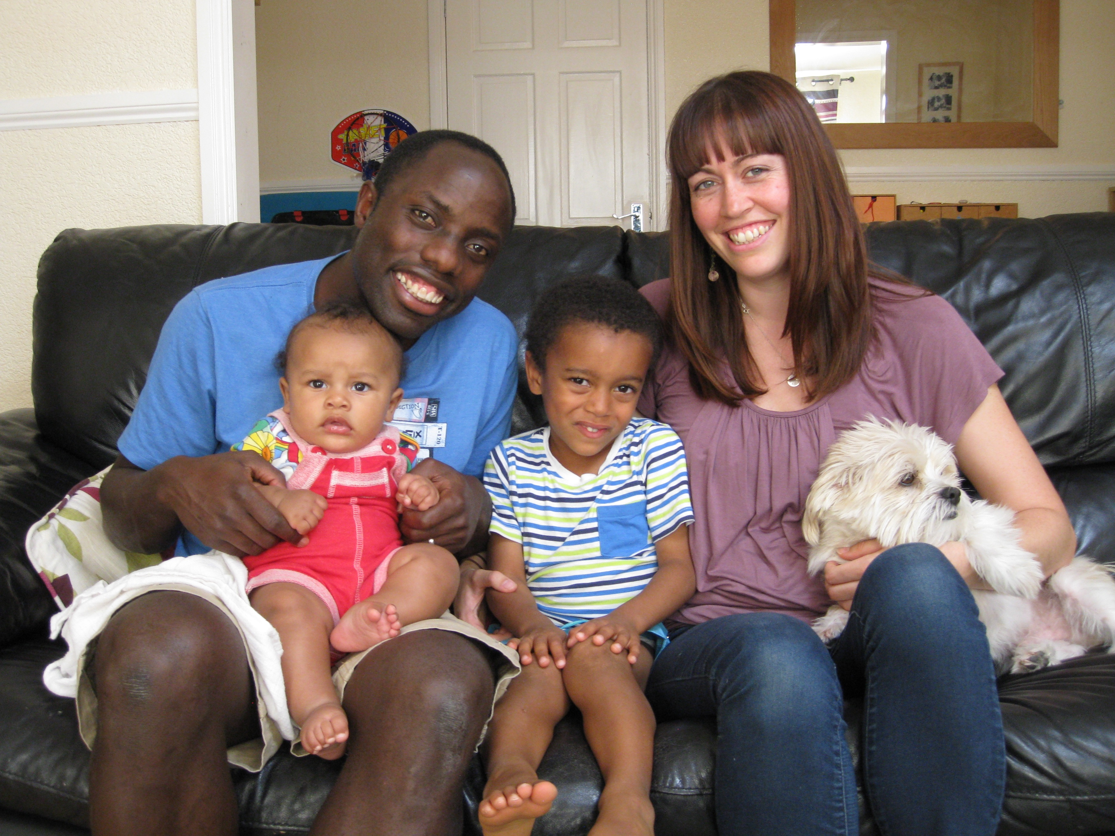A children’s observational documentary series returns to the CBeebies channel from Monday 11 April, fresh from winning acclaim and strong ratings with its debut run earlier this year.

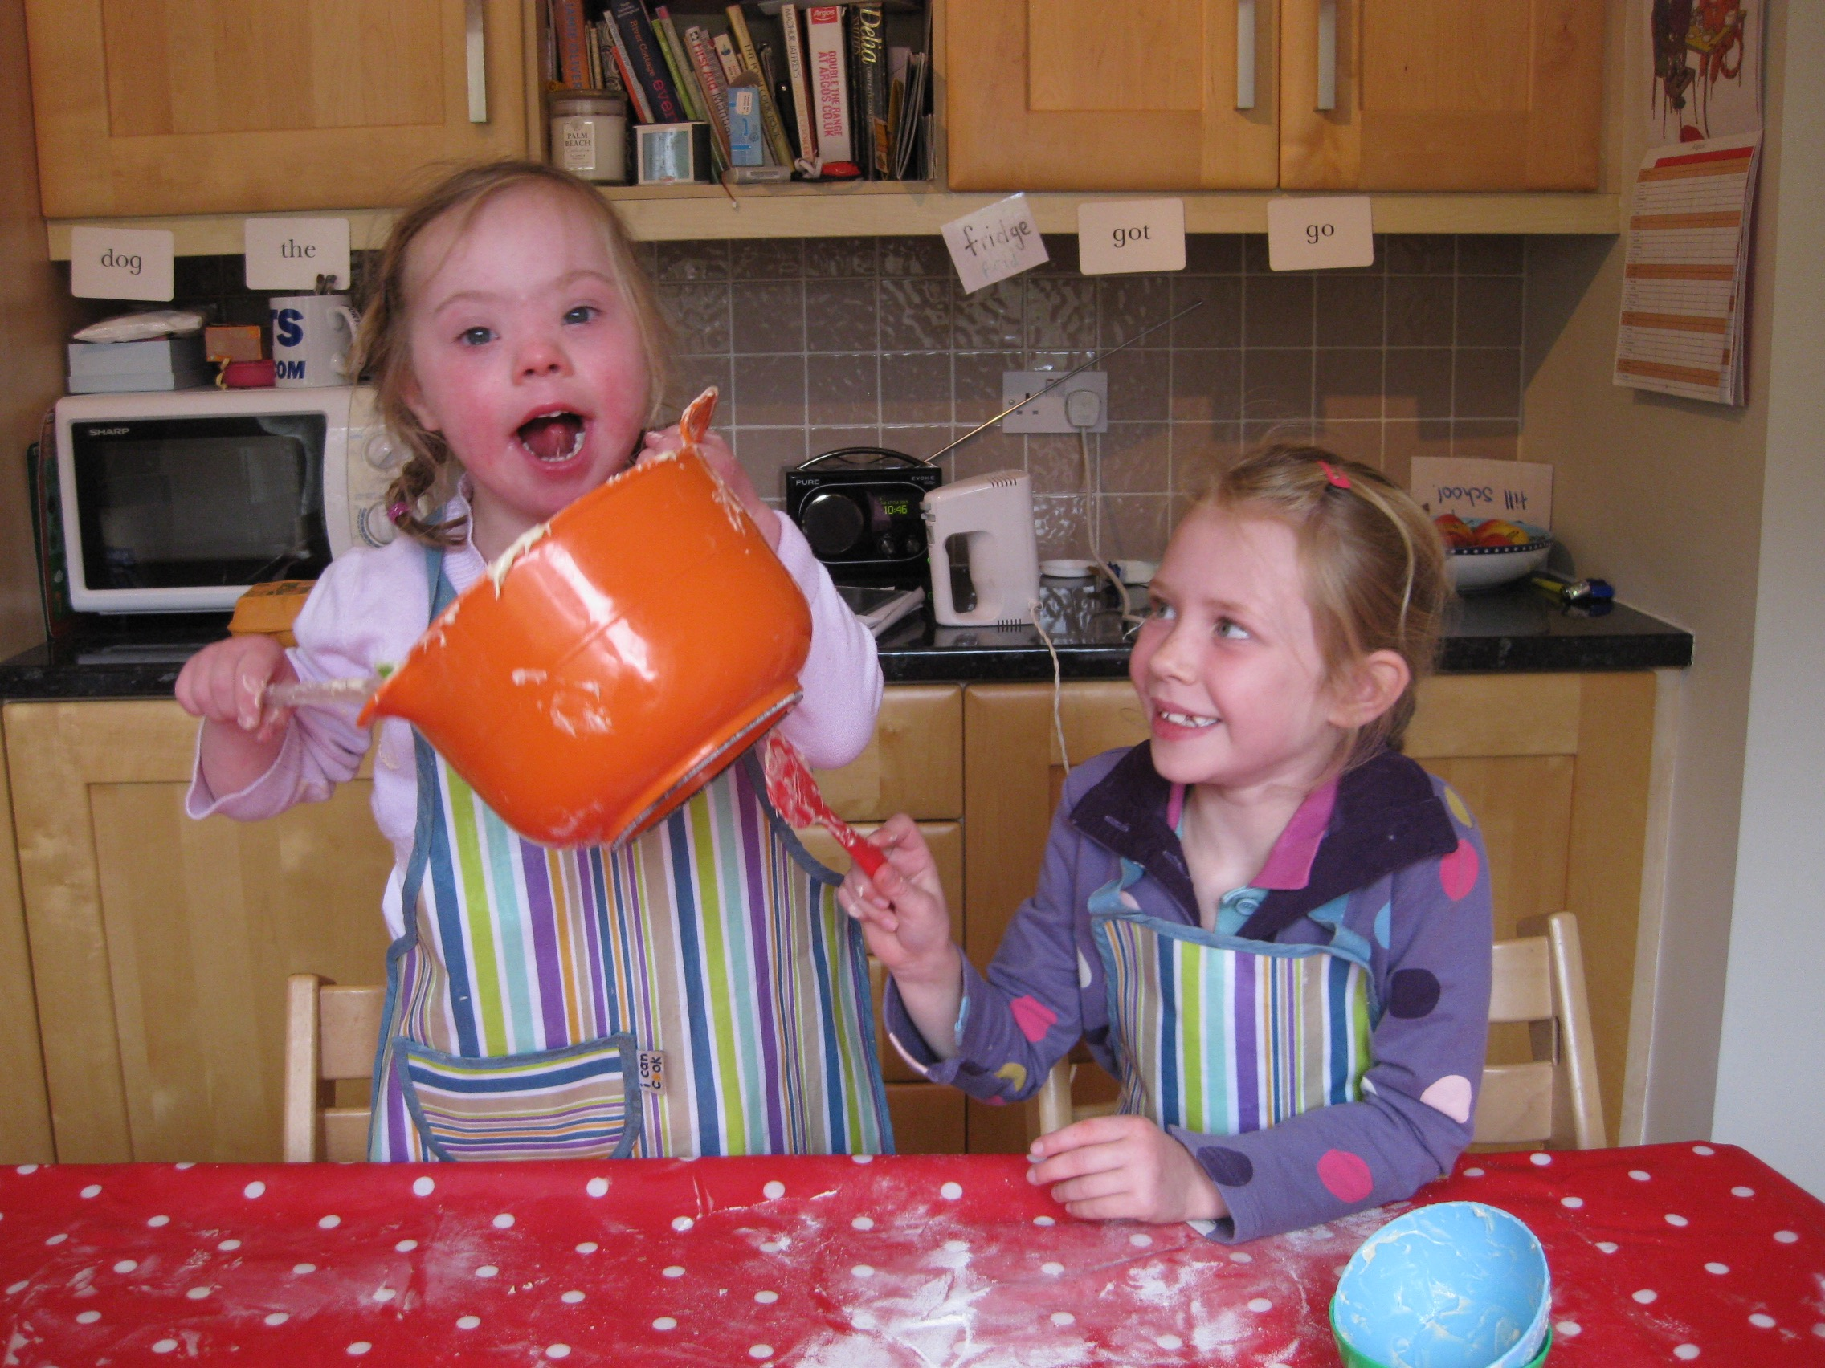Series 2 of **Our Family** continues to follow daily life through the eyes of eight young children and their siblings, who hail from a variety of backgrounds and locations across the UK. Episodes include family trips to Edinburgh Castle, a celebration of Eid, window cleaning, wheelbarrow fun, a house move and a family birthday celebration for the five-year-old dog Sketch! The series is narrated with warmth and humour by CBeebies favourite, Rebecca Keatley (**Let’s Play**).

Since its debut in February, **Our Family** has been widely acclaimed for its unique perspective on the observational documentary genre.

Sallyann Keizer, Creator and Executive Producer of **Our Family**, said: “I have always loved observational documentaries that follow children as they grow, but they’ve been from the perspective of an adult looking down. So with **Our Family**, I wanted to create a show that’s specifically from the child’s point of view: for young children, about young children.

“Series 2 of **Our Family** continues and develops the approach we set with the first 20 episodes. The series remains both wondrous and charming at the same time – it’s entertaining and informative, for children and parents alike. Thanks to our young contributors, and their parents, grandparents, families and friends, we’ve managed to capture those magical moments and times that remind us how enchanting childhood can be and how special family life is.”

In addition to winning praise for its innovative approach to the genre, **Our Family** has also been acclaimed for its sensitive and inclusive portrayal of children from diverse backgrounds. These children include five-year-old Zoe, who has Down’s Syndrome and lives with her mother Sarah, father Gareth and six-year-old sister Charlotte.

Sarah, Zoe’s mother and Chair of Down’s Syndrome Support Group, Stepping Stones DS, said: “I am incredibly proud of the positive response that **Our Family** has received from within the Down’s Syndrome community. This is because of its success in showing a child with Down’s Syndrome just being a child and living a happy, normal life. The series could be considered game-changing as it does not highlight Zoe's disability or single her out as being different in any way.

“**Our Family** shows Zoe lives a fully inclusive life – she attends the same local mainstream school as her sister, has lots of friends and is doing really well. The series really highlights the fact that children and young people with Down’s Syndrome deserve the opportunity to be included in their communities and educated alongside their friends.”

The makers of **Our Family** have also been struck by the positive response to Zoe’s portrayal in the series.

Sallyann Keizer said: “I have been incredibly touched by people’s response to **Our Family**, especially Zoe’s episodes.

“The original idea behind **Our Family** was to reflect the beauty and diversity of family life today in the UK, and to celebrate the differences as well as similarities. Zoe’s episodes have really challenged people’s perceptions and made them look at Down’s Syndrome in a different light. I even received a message from a mum saying that Zoe writing in our show had inspired her daughter with Down’s Syndrome to start writing!”

**Our Family** is a Sixth Sense Media Limited Production for CBeebies. Executive Producers are Nick Wilson and Sallyann Keizer; and for CBeebies, Michael Towner.

**Our Family Executive Producer Sallyann Keizer, plus families featured in the series, are available for interview.**

For interviews, image requests and all media enquiries please contact:  
David Bassom  
E: [mail@davidbassom.com](https://uk-mg42.mail.yahoo.com/compose?to=mail@davidbassom.com)  
T: 07738 803612

**Notes to Editors**Series 2 of **Our Family** (20 x 11’) airs Monday to Friday at 5.20pm on CBeebies from Monday 11 April. **Our Family** is a Sixth Sense Media Limited Production for CBeebies. Executive Producers are Nick Wilson and Sallyann Keizer; and for CBeebies, Michael Towner.

Series 1 of **Our Family** is currently available to view on BBC iPlayer and can also be purchased at the BBC Store.

Sixth Sense Media is a multi-award-winning independent TV production company, whose team has won BAFTA Awards and a prestigious International Emmy Award. The company’s credits include the CBeebies series **Time For School** and **Our Family**, CBBC’s **My Life**, and Channel Five’s **School**, **Stepping Up** and **Make It Big**.

Find out more at http://www.6sense.co.uk and follow us on Facebook www.facebook.com/SixthSenseMediaUK/ and on Twitter at @sixthsensemedia

ENDS