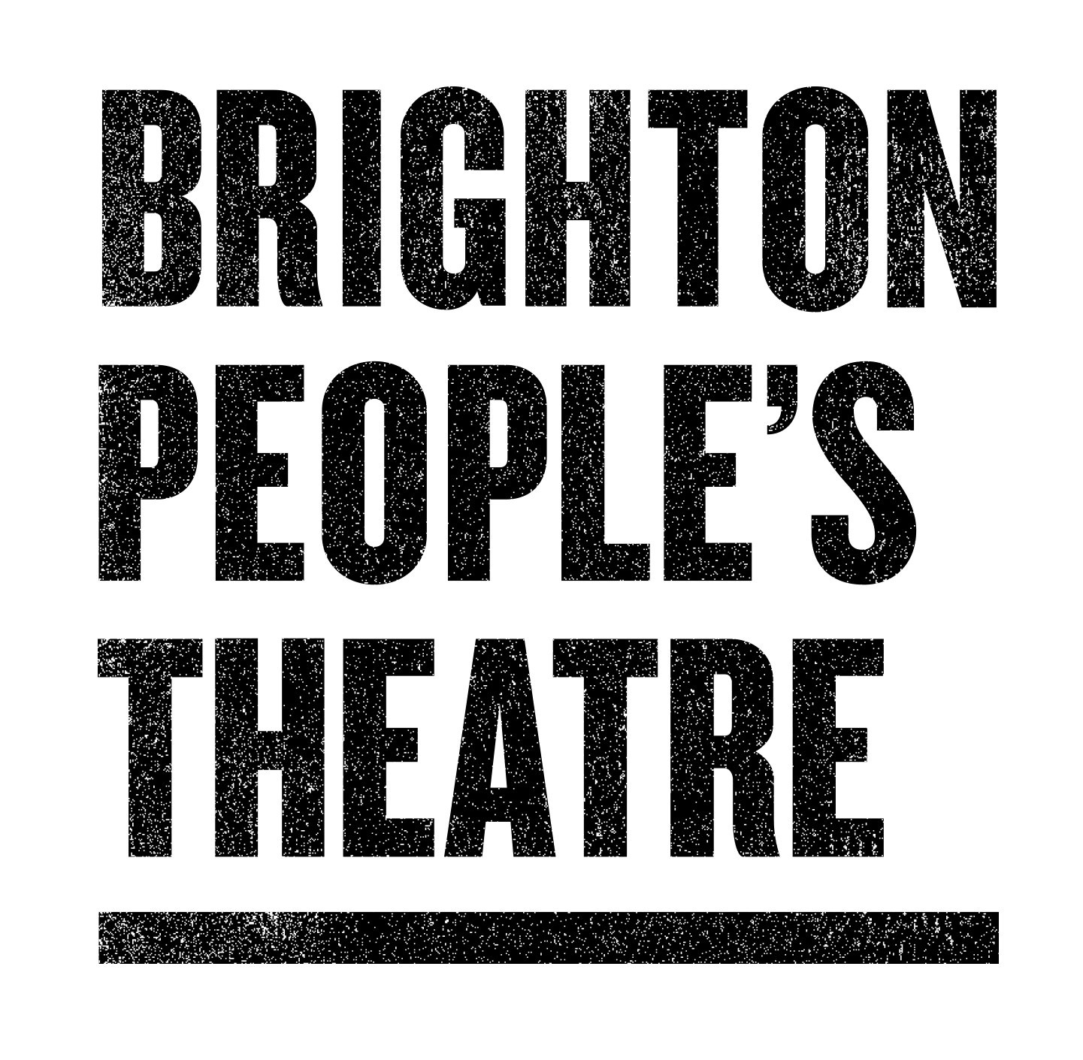
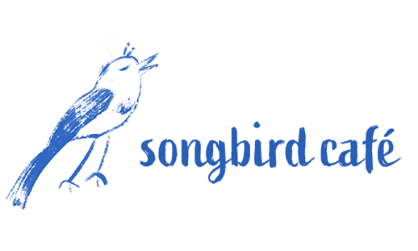
PRESS RELEASE - for immediate release

image credit: Julian Howell, BPT Member

Brighton-based theatre company is looking for local people to get involved in creating their new show

The Songbird Café is Brighton People’s Theatre’s (BPT) new show in development, under commission from Brighton Festival with a view to being performed in 2023.

It will be a family friendly musical that tours to local parks; a magical cafe that has portals in booths that transport the audience to other worlds in different parts of the park. During the day, plans are for it to be an actual cafe that serves coffee while live music is performed. At night it will transform into the set for the new show.

The idea behind The Songbird Café is to explore the crisis in mental health, loneliness and isolation which BPT members have said is the most pressing theme currently, something that has only been exacerbated further by the pandemic.

The show will create a metaphorical world that will explore these themes but won’t necessarily be about them. Brighton People’s Theatre hope The Songbird Café will be an uplifting experience for all the family, bringing local people together to sing, dance and have a good night out.

Ideas for The Songbird Café will be developed between January - June 2022. A creative team of four different artists will each work with local people and lead on the development of their art form, in collaboration with Naomi Alexander, BPT’s Artistic Director, who is directing the production.

They don’t know what the story is going to be yet, or who the characters will be. They don’t know what the set and costumes will look like, what the music will sound like, or what the songs or dances will be.

They want to discover all of this with you, the people of Brighton and beyond during 2022.

They’re looking for local people with an interest in creative writing, performing, dancing, songwriting and singing, and set and costume design to be a part of bringing The Songbird Café to life.

They’re not looking for professionals. They want to meet people who have some experience or enthusiasm for an art form but may not have had many opportunities to develop it.

If this sounds like you and you are excited by the idea of being a part of The Songbird Café, why not get involved? Register your interest to be part of the research and development process by Thursday the 20 January.

Register your interest here.

Naomi Alexander of Brighton People’s Theatre says:

“We are really excited to be making our next show, The Songbird Café in 2022. We have a cracking team of artists who are looking forward to meeting and creating the story, the set and costumes, the songs and the dances with local people. We’re looking for people who love to be imaginative and enjoy working with others. We are really grateful to Arts Council England for funding and Brighton Festival for commissioning the research and development of our show.”

Beth Burgess, Brighton Festival Executive Producer says:
“The Songbird Café builds on our valued partnership with Brighton People's Theatre, and the Our Place communities we have been working with for the past few years. This project puts community at the centre of its creation, and we couldn’t be more excited to see it develop over the next year.”

The Creative Team are:

- Naomi Alexander, Director
- Luisa Hinchliff, Producer
- Rebecca Manley, Writer and Lyricist
- Kane Husbands, Choreographer
- Tim Simpson (Plunge Creations), Set and Costume Designer
- Guy Hughes, Composer and Lyricist

For further information, images and interview requests please contact:
Niamh Hicks, Marketing and Comms Manager niamh@brightonpeoplestheatre.org

NOTES TO EDITORS

Development dates:
Saturday 29 January 2022 10am – 5pm
Sunday 27 February 2022 10am – 5pm
Sunday 27 March 2022 10am – 5pm
Sunday 24 April 2022 10am – 5pm
Performers rehearse every Tuesday evening in May 2022 with the Directors
Saturday 11 June 2022 10am – 5pm (sharing to friends and family)

About Brighton People’s Theatre:
If all the world’s a stage, then theatre is for everyone. Curtain up. Come and play.

Brighton People’s Theatre is changing the way we make theatre and how we tell the tales of our city, for our city. It’s theatre for all: theatre without boundaries.

We believe the power of the arts can transform lives, build communities and improve wellbeing but we know not everyone has equal access to creative activities or that activities are designed with all communities in mind. We prioritise working with communities who have the fewest opportunities and co-design our activities with those communities.

Our activities are open to people over the age of 18, with a BN postcode, and who have never worked professionally in the arts.

Website: www.brightonpeoplestheatre.org
facebook.com/brightonpeoplestheatre
twitter.com/BtnPeople
instagram.com/brightonpeoplestheatre

About Brighton Festival:
About Brighton Festival

Established in 1967, Brighton Festival is the largest and most established annual curated multi-arts festival in England. Taking place over three weeks in May, the Festival is a celebration of music, theatre, dance, art, film, literature, debate, outdoor and community events in venues and locations across Brighton, Hove and East Sussex.

Since 2009, Brighton Festival has attracted inspiring and internationally significant Guest Directors who bring cohesion to the artistic programme. The inaugural Guest Director was Anish Kapoor (2009) and has subsequently included prominent cultural figures such as Brian Eno (2010), Laurie Anderson (2016), Kae Tempest (2017), David Shrigley (2018), Rokia Traoré (2019) and Lemn Sissay MBE (2020/21).

Brighton Festival 2022 will be led jointly by Syrian architect and author, Marwa al-Sabouni and Brighton-based theatre artist Tristan Sharps, as the first guest co-directors to be invited to collaborate together on the programme.

brightonfestival.org
Twitter: @brightfest
Instagram: @brightonfestival
Facebook: brightonfestival

