P R E S S R E L E A S E
FROM: Room to Reward
DATE: 03/05/2018
F O R I M M E D I A T E R E L E A S E
Hospitality Industry Comes Together to Give Volunteering Veteran Break of a Lifetime
The hotel industry has, through an innovative initiative, come together to give thanks to a veteran of volunteering with a stay at her dream hotel.
After a long and varied career in hospitality, Denise Haugh turned her hand to volunteering with industry charity Hospitality Action. Now, her generosity towards others has been recognised with a short break courtesy of’ Room to Reward’ - a unique charity created to say ‘thank you’ to the Hidden Heroes – exceptional charity staff and volunteers - in the form of a couple of nights away in a partner hotel.
Denise has been an invaluable help to Hospitality Action and impacted thousands of lives through her commitment to the cause, as Mark Lewis, CEO of the charity, explains:
“It’d be easier to list what Denise hasn’t done for our charity, than what she has. She has visited grant applicants to offer support with their applications. She has hosted lunches and teas for our Golden Friends (retired industry members who find themselves isolated or lonely). She has been a volunteer visitor since the scheme started in 2006 and has made a huge impact on the wellbeing of the Golden Friend she supports.
“Despite all this, in 2013, Denise decided that she could still do more to support Hospitality Action, so she offered to volunteer at our office in Farringdon. She quickly became an invaluable member of the team, and now spends a day a week with us, supporting HA’s Golden Friends scheme.
“Every year, Denise writes around 2,000 birthday and Christmas cards to our Golden Friends (sadly, for some, these are the only cards they receive). And, every two months, she stuffs, labels and franks 1500 Golden Friends newsletter mailings.”
Room to Reward works on a simple premise. Partner hotels donate their anticipated unsold rooms to the initiative, registered charities are invited to nominate their Hidden Heroes for a break who can then choose from over 150 hotels throughout the U.K.
For Denise, the nomination was extra-special. Her choice – the Balmer Lawn Hotel and Spa – meant the realisation of a lifelong ambition.
“When I was a teenager I was horse mad. I spent every weekend and most of my school holidays at Billy Walsh's stable on Ham Common.” She said.
“Many times, in a horse box, I visited the New Forest where Lord Cowdray's team were playing Ham. I vowed to myself that one day I would be a guest at the Balmer Lawn. I am now almost 82. Thank you for making it possible.”
Michael Clitheroe, General Manager of the Balmer Lawn Hotel, said:
“Denise was the most wonderful guest to look after. She encapsulates the true spirit of her work and the love and comradery of the Hospitality Industry. Not only was it so rewarding for me to be able to look after Denise for her room to reward stay but also to hear the back story of why this hotel meant so much to her”
For more information about the work Hospitality Action does, visit: www.hospitalityaction.org.uk.
For more information on how Room to Reward is giving back to society’s Hidden Heroes, visit: www.roomtoreward.org.
For rooms, events, weddings and other information about the Balmer Lawn Hotel, visit: www.balmerlawnhotel.com.

Notes for Editors
‘Room to Reward’ is an exciting new registered charity that was launched in July 2015. Since its launch, over 135 hotels are now supporting the scheme. Over 190 hidden heroes have been nominated from various charities. ‘Room to Reward’ is the first of its kind in the hospitality industry. Hotel partners donate their anticipated unsold rooms to reward deserving charity workers with complimentary hotel breaks across the UK.
http://www.roomtoreward.org/
Registered Charity 1160675
Photo Captions:
- Denise is presented with her certificate by Mark Lewis, CEO of Hospitality Action
- Adam Terpening (Charity Director – Room to Reward) Hidden Hero Denise and Michael Clitheroe (GM of Balmer Lawn Hotel) in front of the iconic staircase at the hotel.
- Room to Reward Logo
- Hospitality Action Logo

For further information, contact joe@roomtoreward.org

1.

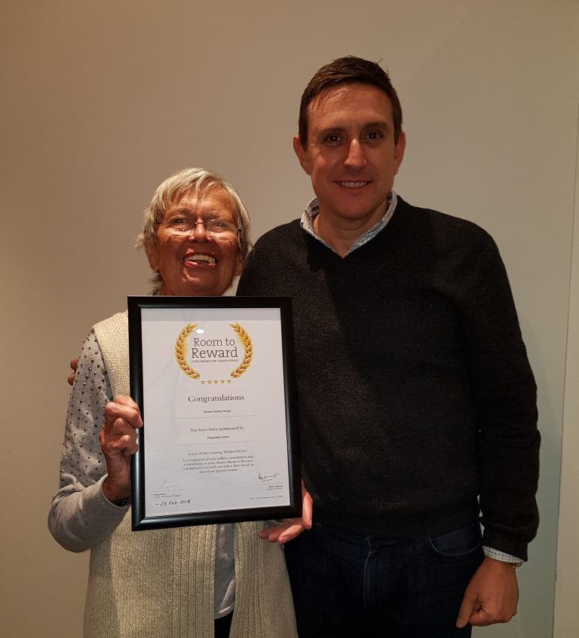

2.
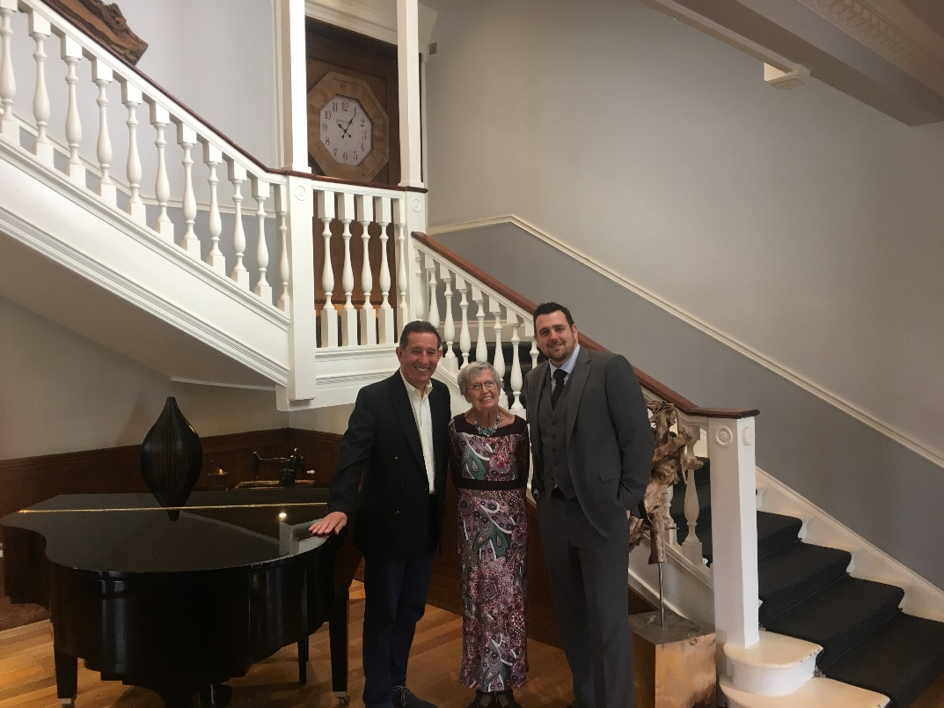

3.
4.
