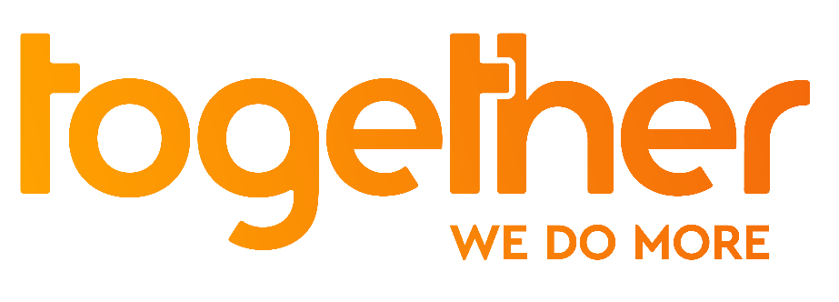

Wild Wild Web
The wild web culture comedy quiz show

The brand-new comedy quiz show featuring YouTubers. Instagrammers and comedians and hosted by YouTube star Humza Arshad

Watch the trailer>>

Pictures and stills available upon request

London, 19th March – A brand spanking new and original web culture quiz show is coming to Together, hosted by YouTube Creator for Change Humza Arshad and his squad of comedians and Insta-stars.

In a journey through the good bad, ugly and downright weird of the internet, the 80-million views Youtuber Humza will be accompanied by Omar Mohidin, Sanj Surati, Rio Fredrika, Archie Manners, Hakkan Hassan, Holly Brockwell, Melanie Gayle, Klayze Smith, Nicola Hume and Nicola Kill.

Think A League of Their Own meets 8 out of 10 Cats meets Would I Lie To You, each week, the two teams play rounds involving skills, mimicry and play head-to-head in the final. Each show wraps up with Humza’s Heroes, looking at the great causes viewers can support online.

Together, the TV channel launched in January, will be airing the 10-episodes show starting Friday the 23rd March, with new episodes weekly on Fridays at 10pm.

Dhanny Joshi, Managing Director at Big Deal Films, said: “Working with Youtubers, bloggers, comedians to produce this TV show has been amazing. We wanted to give voice to talents representing diversity and ready to break into TV. We are grateful to Together for giving us this stage, it is thanks to platforms like Together that make us bigger for the future.”

Alexander Kann, Chief Executive of Together said: “We have commissioned this series as we want to celebrate the best of the web and create a platform to nurture new talent, both on-screen and off. It shows viewers how the web can offer opportunities to do good, for themselves and for others, from the creative tools we now have in our pockets, to amazing causes viewers can get involved with..”

Along with the show, Together wants its viewers to get involved in their communities. Project Dirt is the network that, partnering with the TV channel, uses the internet to bring together over 3,500 local community projects across the UK, connecting grassroots groups with local people, organisations and businesses who are making their community a better place to live.

ENDS

For further information, photos, videos or an interview with a spokesperson, please contact:

Francesca Aita
Marketing Manager, Together
francesca@togethertv.com
07482 251 330

Notes to Editors

About Together
Together is the ‘do more’ TV channel. Optimistic, encouraging and celebrating the quirks of British life, we motivate viewers to do more for themselves and those around them through smartly-entertaining series and motivating documentaries.

Available 24-hours-a-day, our programming is geared around wellbeing (Better Together), creativity (Make Together) and community (Get Together).

Together broadcasts 24-hours on Freeview 93, Sky 539, Virgin 269 and freesat 164, and available streamed and on-demand through www.togethertv.com, TVPlayer, DailyMotion, YouTube, Facebook and BT TV.

Together is owned by over two hundred individual shareholders with a wider group of donors and backers including Sky, Big Lottery Fund, Barrow Cadbury Trust, Channel 4, ITV, BBC, Unltd and Social Investment Business

Together’s launch has been supported by gifted media inventory from companies in the public service broadcasting, channel groups, newspaper groups and tech giants.

To receive Together on Freeview, viewers will need to be within coverage and be watching through Freeview HD or Freeview Play devices. Some viewers may need to retune. Viewers can check predicted coverage at: www.freeview.co.uk/channels-at-your-address

www.togethertv.com

ENDS

