PRESS RELEASE

For immediate release: 11 September 2017

CHILDREN BACK AT SCHOOL-TICK! BUT HOW ABOUT YOU? IF YOU’RE THINKING ABOUT YOUR NEXT STEPS, THIS NEW BOOK IS FOR YOU.

‘A NEW WAY FOR MOTHERS’ A REVOLUTIONARY NEW BOOK

Back to school isn’t just an opportunity for children to start afresh, explore their skills and talents it can also be an amazing time for mothers and parents. Finding the best way to do this can, however, be challenging. But a recently launched book ‘A New Way for Mothers,’ written by the Founder of Beyondtheschoolrun.com, has been created to help you do just that.

Louise Webster, Founder of award winning website www.beyondtheschoolrun.com, wrote ‘A New Way for Mothers’ to provide inspiration, encouragement and a step-by-step approach for every mother wishing to engage her talents during the hours her children are at school. Louise recognised on her journey into motherhood that there is an incredibly important yet untapped wealth of talent amongst mothers who have put aside their career aspirations or creative outlets to prioritise their family. These women face a huge challenge in re-connecting with the professional world again in a way that recognises their need to continue to be available for their children.

The book has strategies and tips - from finding the right type of work, to supporting your health - that will help mothers find purpose and balance as their children go through school. Every chapter is filled with guidance and encouragement. These range from ‘Making the Connection’, which talks about connecting firstly with yourself before engaging fully with all aspects of your life, from the school gates to the working world. The chapter headed ‘Happiness’ is about making peace with where you are right now and looking at ways of redefining success. It includes practical advice, such as five things you can do to help you have a fulfilled day.

A New Way for Mothers has received incredible reviews already including:

“ Only half way through but loving it. Since becoming a mum this is the book I have wanted to find. It is feeding my soul. Thank you.” Amazon Review

Louise is a mother of two children and is passionate about the potential collective talent of parents across the world. Louise won Britain’s Top Real Role Model 2014 and has been invited to No.10 Downing Street twice to discuss the business.

Louise Webster, Author says: ”I set out on this journey to find a new way for myself only to discover I wasn’t alone. There is a hugely valuable group within society, parents and mothers whom I believe, with the right inspiration, motivation and opportunities will not only thrive themselves but will help the world thrive too. I hope this book can provide the steps that mothers across the world may be looking for.“

Instead of going ‘back to school’, why not go beyond, take your first step forward and order your copy of ‘A New Way for Mothers’ today. The book is available to buy at www.amazon.com, bookstores and at the Beyondtheschoolrun.com website. To become part of the Beyondtheschoolrun.com community just sign up for their newsletter or join their Facebook group: https://www.facebook.com/search/top/?q=beyond%20the%20school%20run

-ends-

For further information, images or for an interview with the author please contact:

Louise Webster
E: louise@beyondtheschoolrun.com
T: 07979 241 458

Notes to editors:

About the Author, Louise Webster
Louise Webster is a mother of two children. She launched Beyondtheschoolrun.com in March 2012 to help unlock the talents and skills of parents for their well-being and the wellbeing of society. The enterprise has developed a strong community of parents, been featured in a range of media, received two invitations to No.10 Downing Street and was listed one of the 'Top 58 British Tech Startups for 2014' in UK Business Insider. Louise won ‘Britain’s Top Real Role Model 2014; and has become a spokesperson on the subject of mothers and work.

About Beyondtheschoolrun.com
Beyondtheschoolrun.com is the place to inspire, engage and connect parents with their skills and talents in the hours available to them. It was founded in March 2012 and now has a strong community of parents. Beyondtheschoolrun.com communicates regularly with it’s community via it’s newsletter, social media channels, You-tube channel and website. The website has received praise and recognition from media, Government and influencers across the Globe.

About the Publisher
Familius is a family and parenting media publisher devoted to creating content that helps build strong values and happy families. As a digitally savvy, multi-media publisher, we share our family-driven content in multiple formats, including print, e-books, videos, articles and apps. Let’s Talk Family. http://www.familius.com

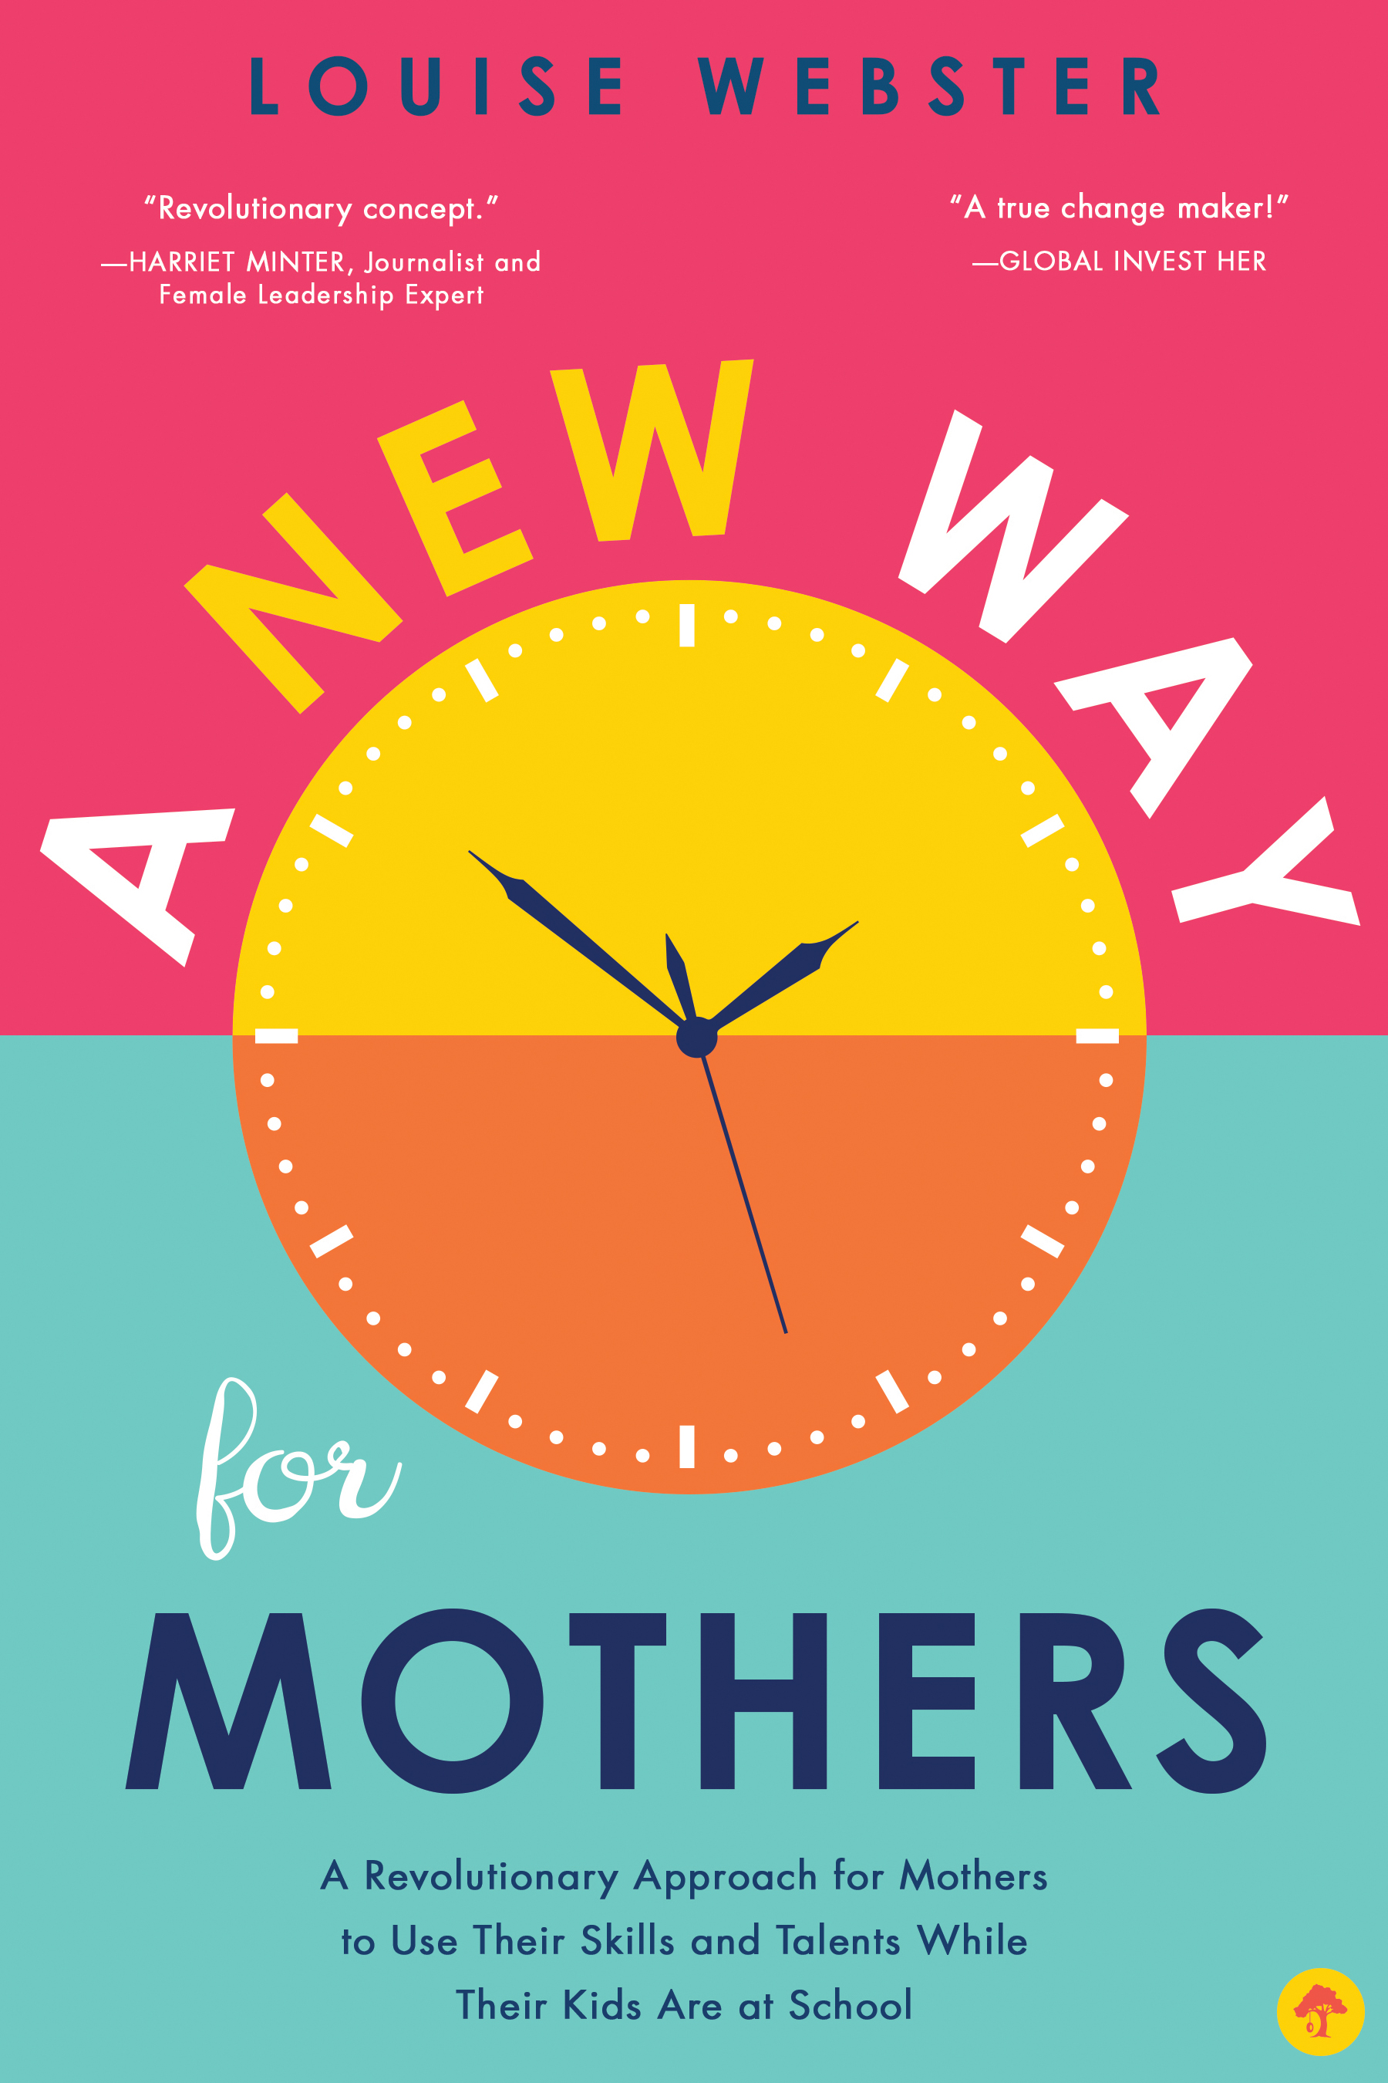

Book Details:
Title: A New Way for Mothers: A Revolutionary Approach for Mothers to Use Their Skills and Talents While Their Children Are at School
Author: Louise Webster
Publisher: Familius
Publication: August 1, 2017
Price: $16.99
ISBN: 9781945547171
192 pages, trade paperback
*Available August 1, 2017 from bookstores, online booksellers and www.familius.com

