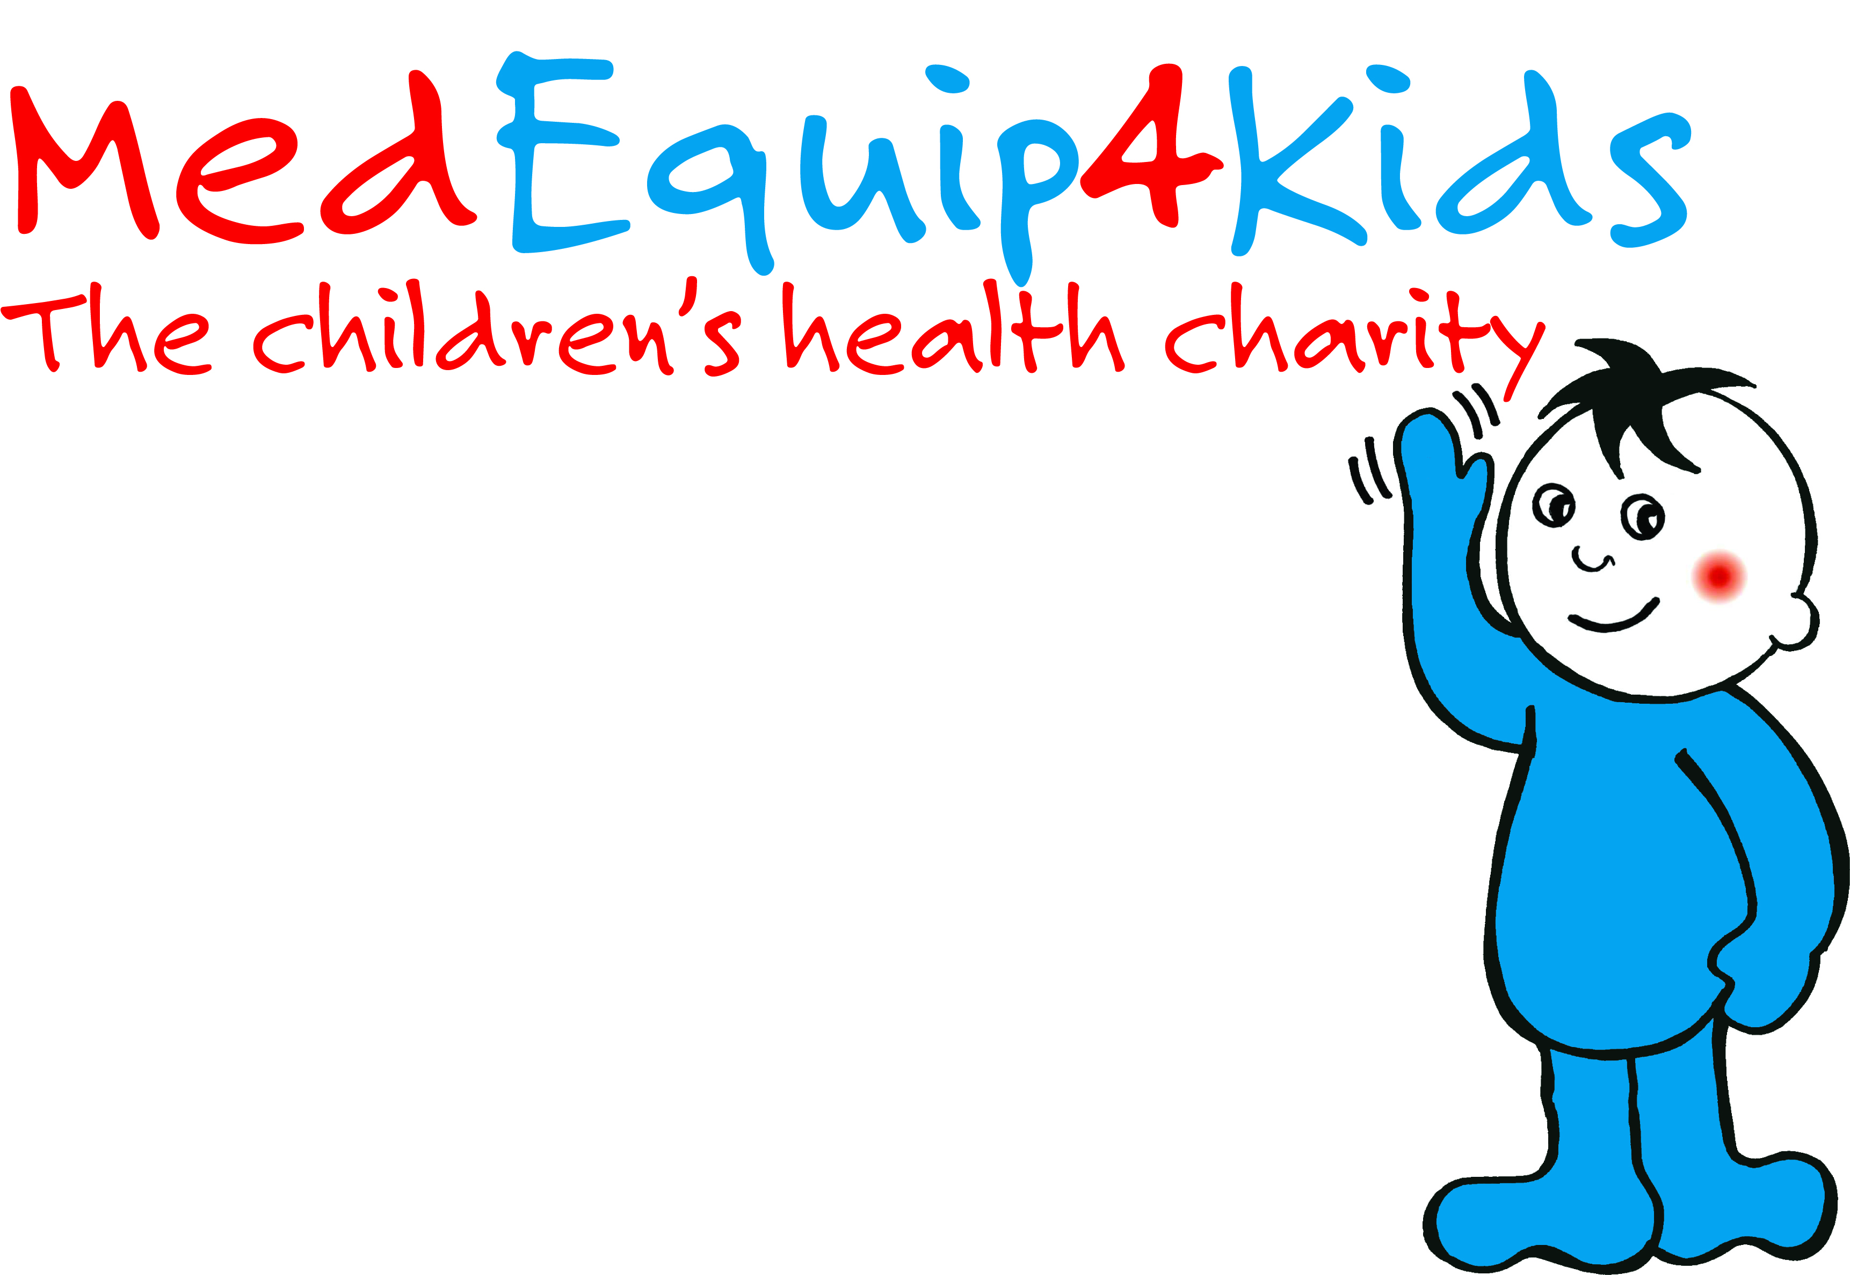

Winstanley College students walk Miles4Kids to support MedEquip4Kids Chair bed appeal for the Rainbow Ward at Royal Albert Infirmary!

Story Highlights
- Winstanley College Students take on a 22 mile walk to help fund for Recondo Sleeper Chairs for the Rainbow Ward at Royal Albert Edward Infirmary
- The event to part on July 1st 2017
- It was a gruelling 22 Mile Walk from Southport Pier to Wigan Pier .
- 17 Students took part.

Winstanley College students walk Miles4Kids.

On the 1st July 2017 Vishal Chahwala , Lana Robinson and the Students from Winstanley College took on an epic challenge of walking a massive 22 miles from Southport Pier to Wigan Pier. The event was a huge success and a test of physical and mental endurance. It was also kindly supported by Prime Care Ambulance Services who provided first aid cover for free and Burscough Methodist Church who opened their doors to provide much needed hospitality at the half way point.

The money they raise will be going to support the much-needed chair beds appeal for the Rainbow Ward at Royal Albert Edward Infirmary. The Rainbow Ward at Royal Albert Edward Infirmary provides care for almost 4.000 children a year. The ward has 34 beds and children often stay on the ward for a number of days or weeks depending on their condition. It is beneficial for children to have 24 hour parental support during their stay in hospital as it reduces the stress upon them leading to quicker recovery and discharge.

Currently there are only 12 chair beds available so the rest of the parents who need to stay have to spend the night sat up in a chair. The bed chairs need to be hardwearing because of the frequent use and fully cleanable for hygiene purposes. They require 10 extra Recondo Recliner Chairs to fill the need for more parent beds and help improve patient experience. MedEquip4kids has now funded 2 beds and are fundraising for the remaining 8 required

Vishal Chahwala , a medical student at Winstanley college said : “We admire and appreciate the work MedEquip4kids do so much and that's why we at Winstanley College want to work with this amazing charity to fundraise for the Rainbow Ward at Wigan Hospital so that they can provide beds for parents to stay overnight, comforting and supporting their children who may be extremely ill.

Sarah Suthers, Community Fundraiser at MedEquip4Kids, says: ‘We’d like to say a very special thank you to the students from Winstanley College for giving up their time and taking an a epic challenge many people underestimate. To Prime Care Ambulance Service for their amazing support to the students and Burscough Methodist Church who provided much needed respite at the half way point. This all made it a fabulous event. Children and babies deserve the best healthcare and it’s crucial that all the right equipment and support are on hand to give them the best possible chance of a healthy future.”

This is the latest appeal in the long list of charitable support that MedEquip4Kids have made to Royal Albert Edward Infirmary.

If you want to support MedEquip4kids and the great work they do please click on www.medequip4kids.org.uk or call 0161 798 1600.

The organisation was set up in 1985 by a couple, after their daughter became seriously ill with meningitis and was treated at Booth Hall Children’s Hospital in Manchester, where she made a full recovery.

At the time, the hospital was unable to afford some vital items of equipment, so to show their gratitude to the hospital that saved their daughter’s life, the couple began fundraising for the equipment. Since then, MedEquip4Kids has raised over £20 million to care for around 128,000 children a year at hospitals across Greater Manchester, Merseyside, Cumbria, Lancashire, Yorkshire and beyond.

- Ends –
ENDS
NOTES TO EDITORS:
1. MedEquip4Kids exists to improve healthcare for children and babies across the north of England by providing specialist paediatric equipment for hospitals and community health teams.
2. MedEquip4Kids was founded in 1985 and, to date, has raised more than £20 million.
3. To contact the charity, call 0161 798 1600 or email info@medequip4kids.org.uk
4. More information on individual projects at hospitals across the region are available via our website: www.medequip4kids.org.uk

