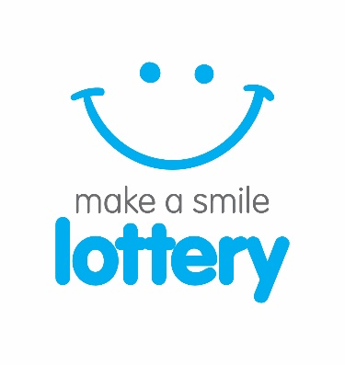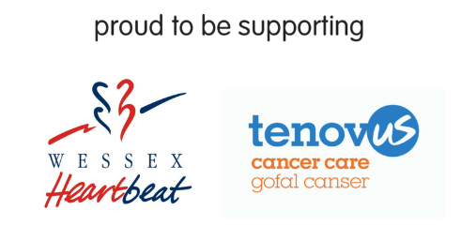
PRESS RELEASE
27th September 2017
The first draw for make a smile lottery is nearly upon us!

`make a smile lottery’ is a brand new venture owned and run by St Helena Hospice with a mission to raise much needed funds to support local causes across Great Britain.
The Colchester-based charity already runs the very successful Your Hospice Lottery, working with nine other hospices up and down the country. The weekly lottery draw has raised over £8 million for hospice care since 2001.
Building on the success of Your Hospice Lottery, the lottery team at St Helena Hospice are venturing outside of the hospice world to support local charities like Wessex Heartbeat and Tenovus Cancer Care with the all new make a smile lottery.
The first make a smile lottery draw is being held on Friday October 13th - join today to be in with a chance of winning in the first draw!
Entry into the draw costs £1 per week, and players have the chance to win one of 16 guaranteed weekly prizes, including a top prize of £250 and a further 15 £10 prizes. There will also be a rollover jackpot of £200 which if not won increases by £200 each week up to a maximum of £10,000! The prize fund will be reviewed regularly and as more people join the draw, the prizes will increase.

From their first entry into the make a smile lottery draw; members will be choosing to help the charity of their choice.

To join players can visit the website www.makeasmilelottery.org.uk or telephone the lottery office on 0300 303 4500.

Alex Howe, Head of Lottery at make a smile lottery commented “We are delighted to be branching out and using our skills and expertise in the lottery industry to work with some amazing charities, helping them generate the income they need. It’s really simple, there are no upfront costs or fees for the charity, we deal with the administration of the draw, all the recruitment of players and the marketing. We are an easy hassle-free option for most charities wanting to make income from a lottery”.

John Munro, CEO of Wessex Heartbeat, said: “We are very excited to be working with make a smile lottery to launch this new weekly lottery draw which will really benefit the charity. It’s an inspirational product which will really help us to engage with our supporters as it’s a nice way for people to get something back but support a fabulous charity at the same time”.
Terry Osborn, Tenovus Cancer Care Director of Income Generation, said: “Playing the make a smile lottery is a great way to support cancer patients and their loved ones. It’s a really important source of income for us, and means that we can continue to fund vital research to help people affected by cancer. Tenovus Cancer Care will receive 75p for every £1 spent on the lottery, which will help our researchers find better ways to treat, prevent and support cancer patients and their loved ones.”

Photocall: Wednesday 11th October 10am

‘First draw celebrations’ at the make a smile lottery office, Phoenix Square, Wyncolls Road, CO4 9PE

For further press information contact:

Sally Thomas, Marketing Manager, make a smile & your hospice lottery, sally@makeasmilelottery.org.uk or 0300 303 4500

About make a smile lottery
Make a smile lottery exists only to raise funds for local charities, is owned and run by St Helena Hospice who receives a small income towards hospice care from each membership for administering the lottery. It costs just £1 per week to play and lottery members are making a difference to people in their local community who benefit from the fantastic local causes that make a smile lottery supports. By working with local causes in this way rather than setting up their own lotteries, overheads and costs are kept to a minimum so more funds can be used for charitable purposes. Members choose which local cause they wish to support with their membership. After running costs and the prize fund are taken out, the rest of every £1 goes directly to support your chosen cause and the fantastic work they do in the community. A team of fundraisers representing make a smile lottery, ask members of the community to play the lottery in support of their chosen charity, and they are paid to do so from a small budget specifically allocated for this purpose. Make a smile lottery is regulated and licensed by the Gambling Commission (number 000-004685-N-306842-006) under the Gambling Act 2005. Lottery members must be 16 or over and a full set of terms and conditions are available online at www.makeasmilelottery.org.uk or from the make a smile lottery office by telephone 0300 303 4500.

